

Universal College Of Engineering, Vasai (E).



Department

Of

Computer Engineering

**Web Design Lab**

**Lab manual**



Universal College Of Engineering, Vasai (E).

**DEPARTMENT OF COMPUTER ENGINEERING**

Lab Manual for the Academic Year 2020-21

(In accordance with Mumbai university syllabus)

SUBJECT : Web Design Lab

SUBJECT CODE : CSL504

SEMESTER : V

BRANCH : Computer Engineering

Subject In-charge

John Kenny

**DEPARTMENT OF COMPUTER ENGINEERING**

**Vision:** To be recognized globally as a department provides quality technical education that eventually caters to helping and serving the community

**Mission:** To develop human resources with sound knowledge in theory and practice of computer science and engineering To motivate the students to solve real-world problems to help the society grow To provide a learning ambience to enhance innovations, team spirit and leadership qualities for students

**Web Design Lab**

Name of the student: Vinay Panchal

Class: TE

Sem: V

Roll No: 59

Batch : A3

**CSL504**

Web Design Lab

**Lab Outcome:**

After successful completion of this course student will be able to:

1. Understand the core concepts and features of Web Technology
2. Design static web pages using HTML5 and CSS3
3. Apply the concept of client side validation and design dynamic web pages using JavaScript and JQuery.
4. Evaluate client and server side technologies and create Interactive web pages using PHP , AJAX with database connectivity using MySQL.
5. Understand the basics of XML, DTD and XSL and develop web pages using XML / XSLT
6. Analyze end user requirements and Create web application using appropriate web technologies and web development framework

**Term Work**

1. Total 25-Marks (Experiments: 10-marks, Attendance: 05-marks, Mini Project: 10-marks)

**Oral and Practical Exam**

1. Based on the entire syllabus of CSL 504: **Web Design Lab**

**INTRODUCTION**

This manual is organized in such a way that the students can directly use it in the laboratory. Each laboratory exercise comprises of

**1. Statement of the problem (Aim)**

**2. Theory**

**3. WDL code**

**4. Output**

**5. Conclusion**

**LIST OF LAB EXERCISES:**

|  |  |  |
| --- | --- | --- |
| **Sr No** | **Name of the program** | |
| 1. | Explain in detail various steps to install and run a .html file using LAMP/XAMP/WAMP server |
| 2. | Create a detailed resume, provide links for all your social media accounts . Use tables ,frames, hyper links in designing your detailed resume |
| 3. | Create a e-commerce website by using HTML, CSS and JAVA SCRIPT |
| 4. | Using php and mysql perform the following operations 1. Create 2. Read 3.Update 4. Delete |
| 5. | Using php and mysql develop a fully functional login and registration form. Add features such as forgot password and password matching |
| 6. | Implement search functionality using Php and ajax |
| 7. | Create a web application using laravel framework. The web application should contain laravels user registration process |
| 8. | Experiment 8 (a) : Write a java program to illustrate the use of simple inheritance  Experiment 8 (b) : Write a java program to illustrate the use of multi level inheritance by using Bank class as an example. The bank class should consist of rateofIntrest() as a method |
| 9. | Host the web application created in Exp 8 using Domain Registration Process. |
| 10. | Mini Project: |

**Experiment 1**

**AIM:** Explain in detail various steps to install and run a .html file using LAMP/XAMP/WAMP server

**THEORY:**

**EXPERIMENT 1**

**AIM :**To explain in detail various steps to install and run a .html file using LAMP/XAMPP/WAMP server

**PROGRAM:** HERE ARE THE FILES I USED FOR HOSTING IN THIS EXPERIMENT

<http://vinaypanchal.com/scratch/>

**PROCEDURE:**

WE WILL GO WITH XAMPP SERVER

**STEP 1**

SEARCH FOR XAMPP ON WEB BROWSER AND CLICK ON FIRST RESULT

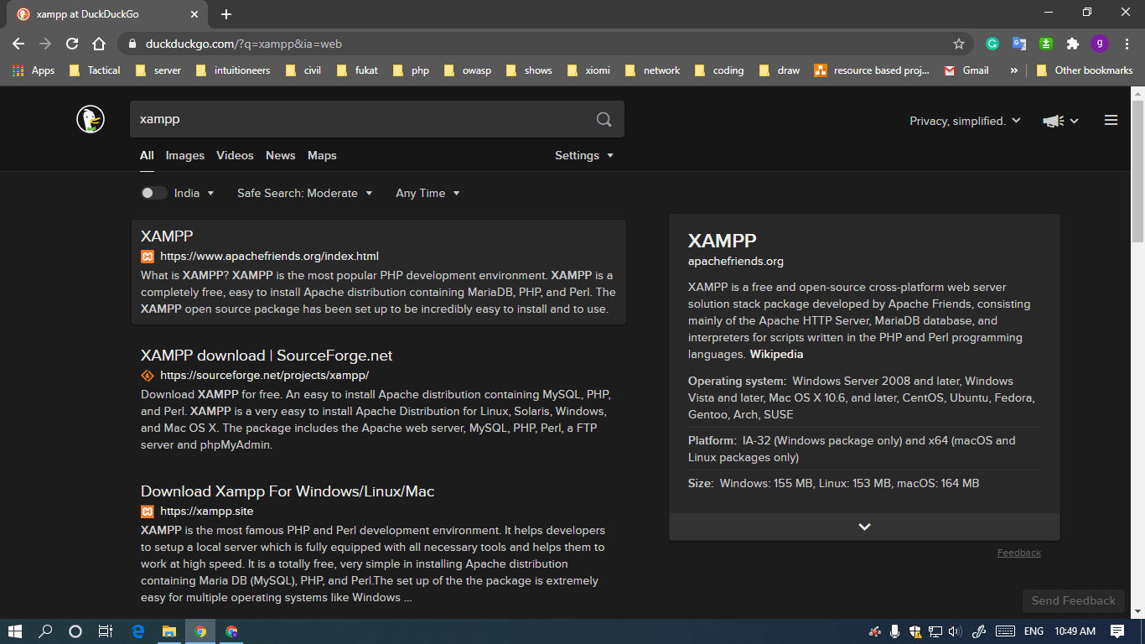

**STEP 2**

SELECT YOUR HOST OS… I WILL GO WITH WINDOWS

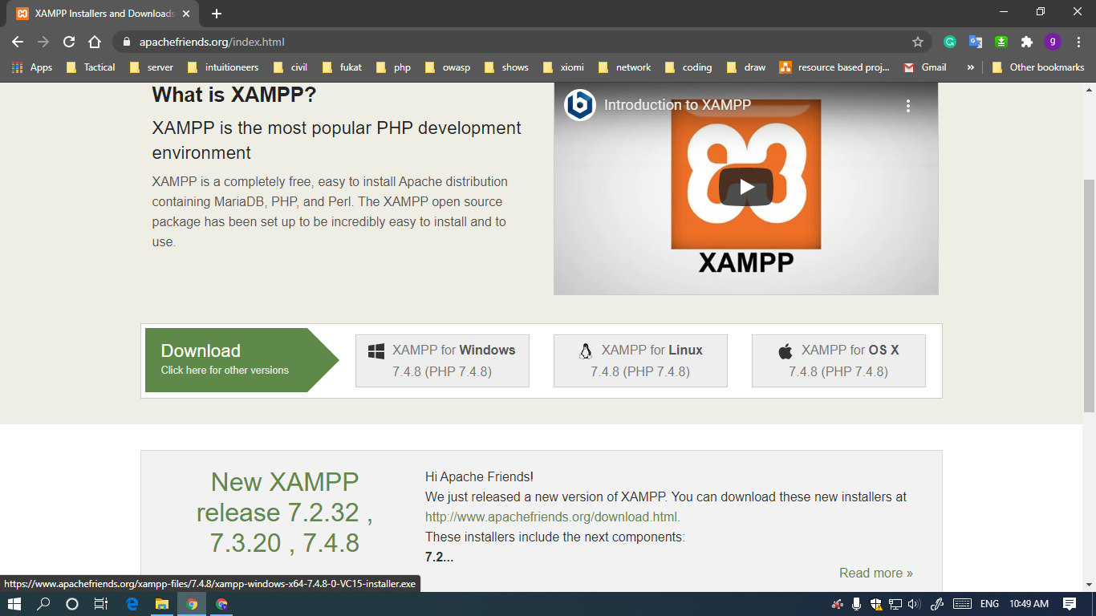

**STEP 3**

WAIT FOR IT TO DOWNLOAD

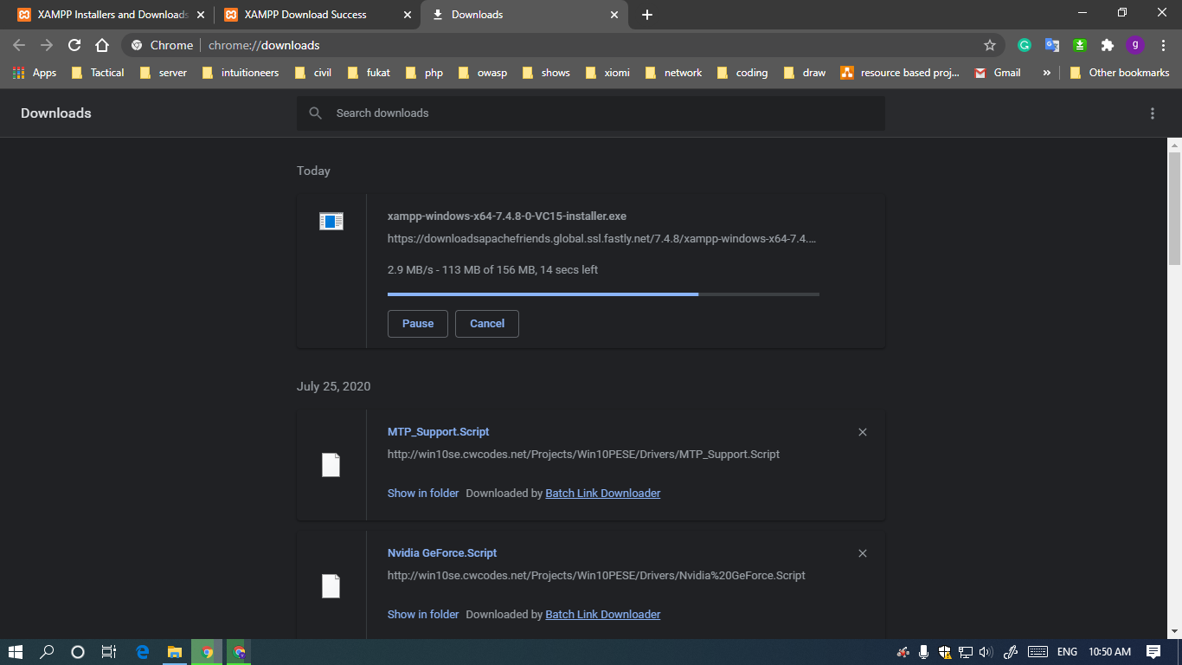

**STEP 4**

OPEN INSTALLATION FILE

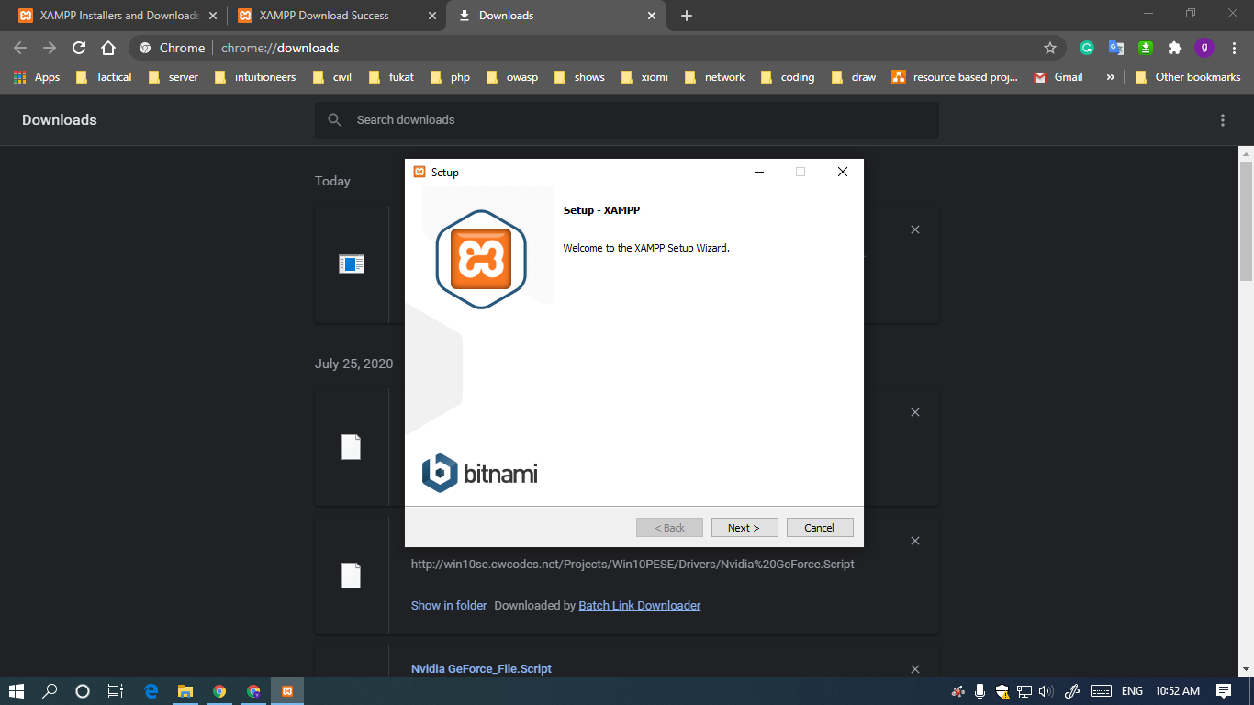

**STEP 5**

KEEP CLICKING ON NEXT BUTTON UNTILL YOU CAN'T

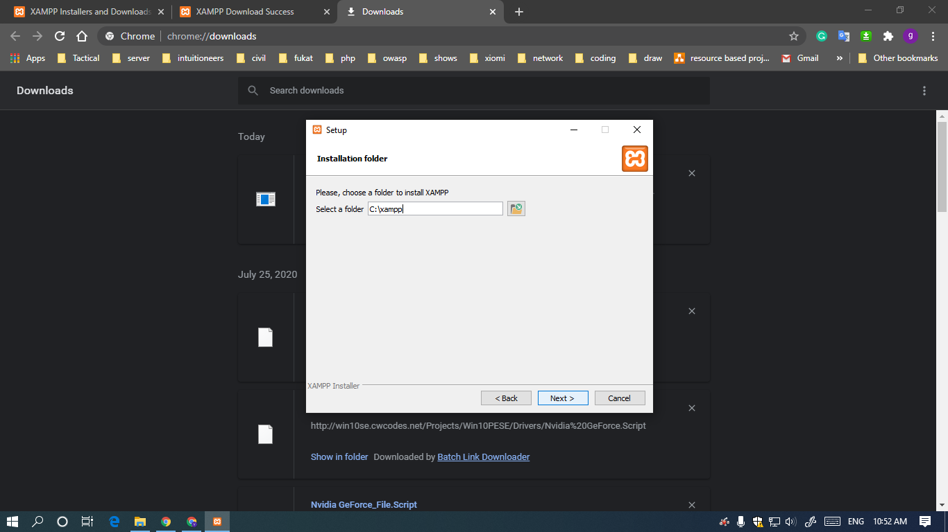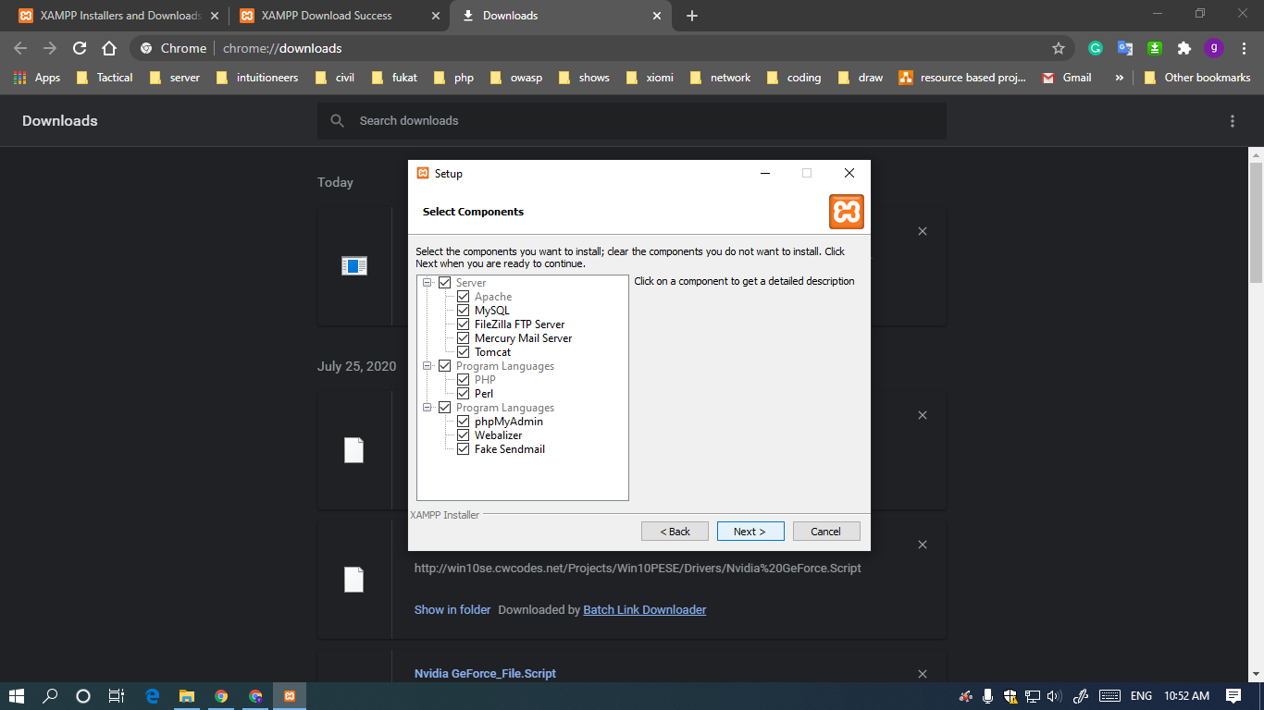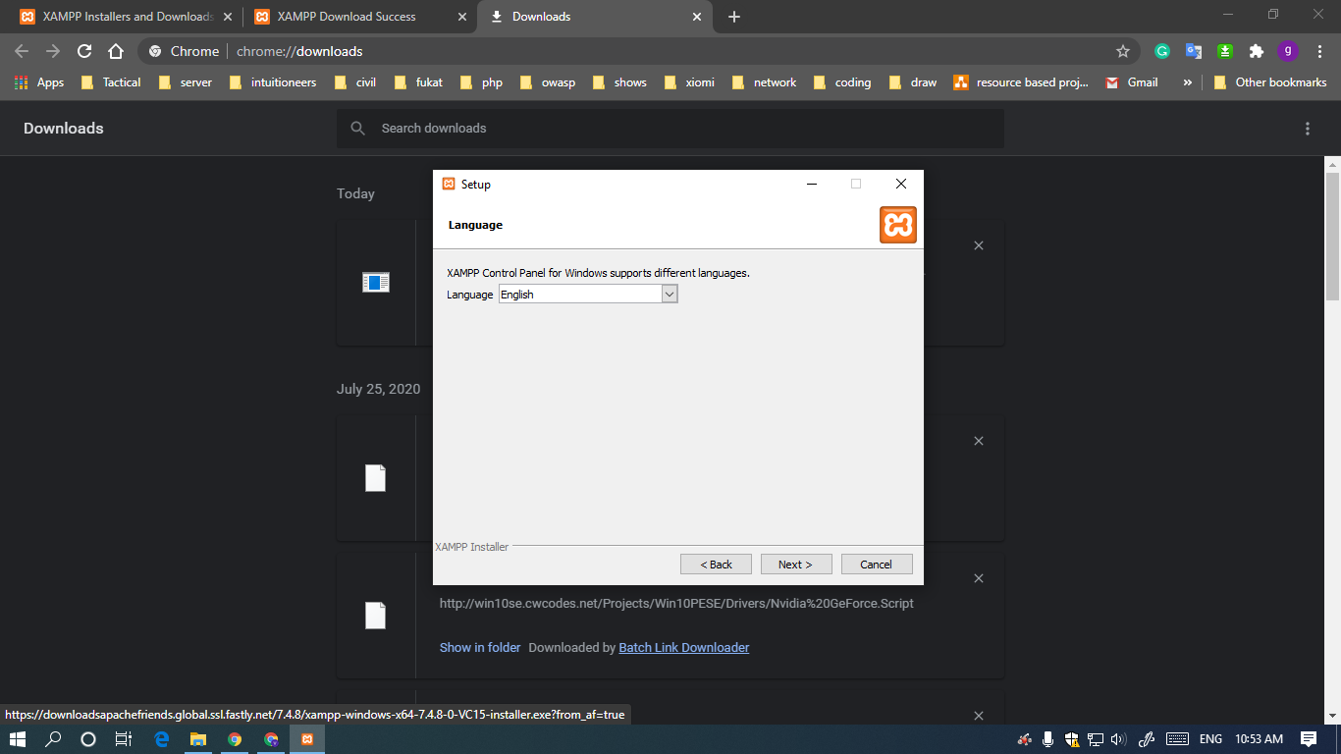

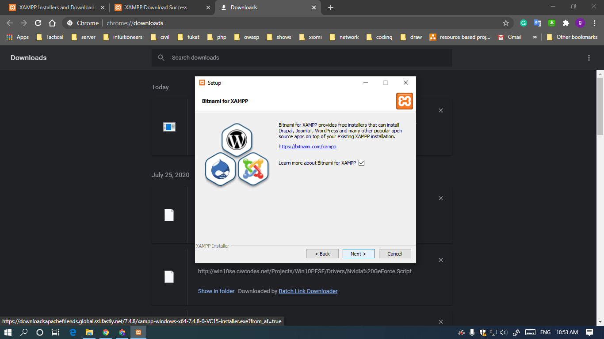

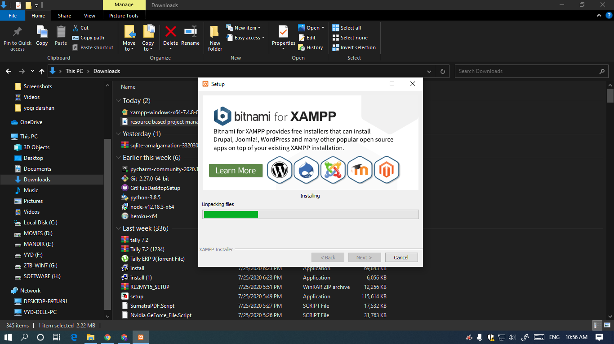

**STEP 6**

CLICK ON FINISH BUTTON

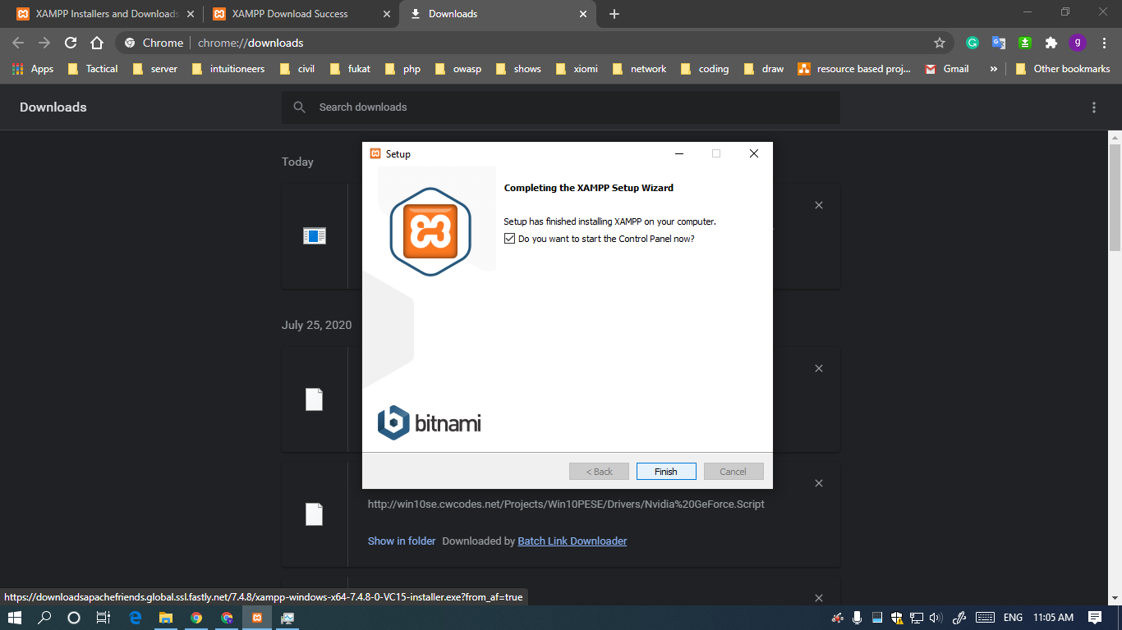

**STEP 7**

OPEN THE PROGRAM YOU JUST INSTALLED

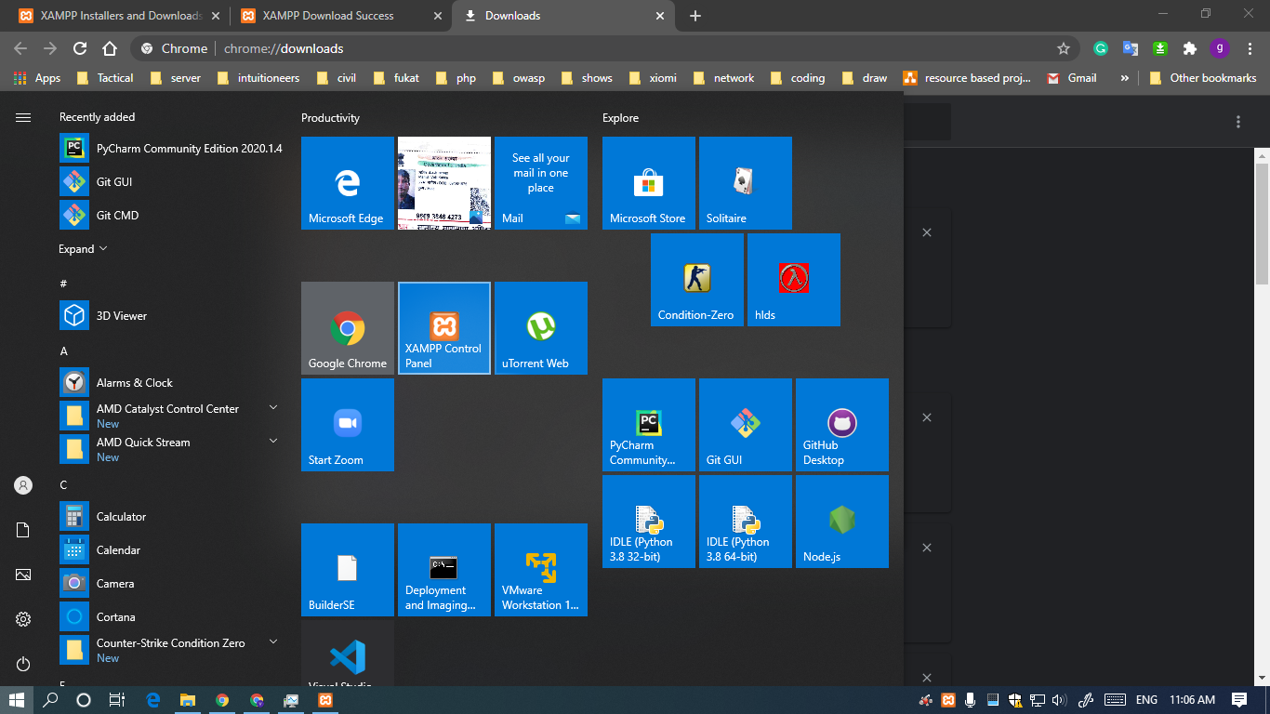

**STEP 8**

GET YOURSELF COMFORTABLE WITH THE UI

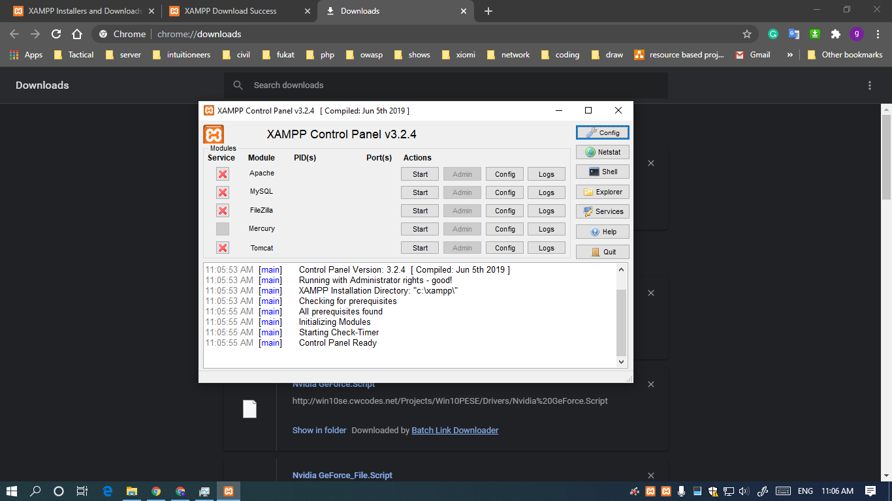

**STEP 9**

TOGGLE START BUTTON OF APACHE AND MYSQL MODULES

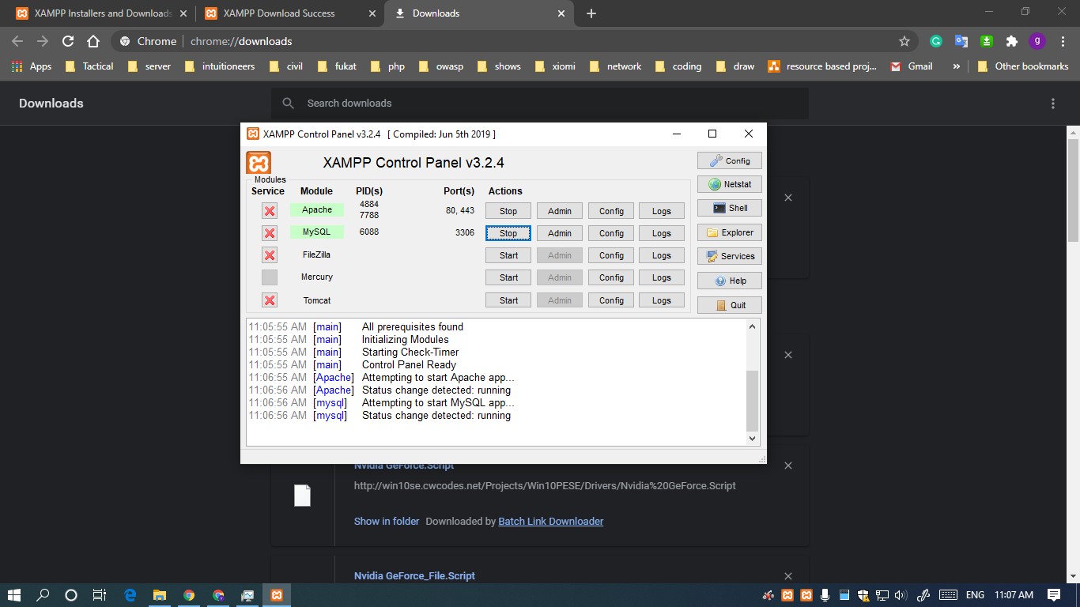

**STEP 10**

MARATHON THROUGH THE DIRECTORY C:\xampp\htdocs

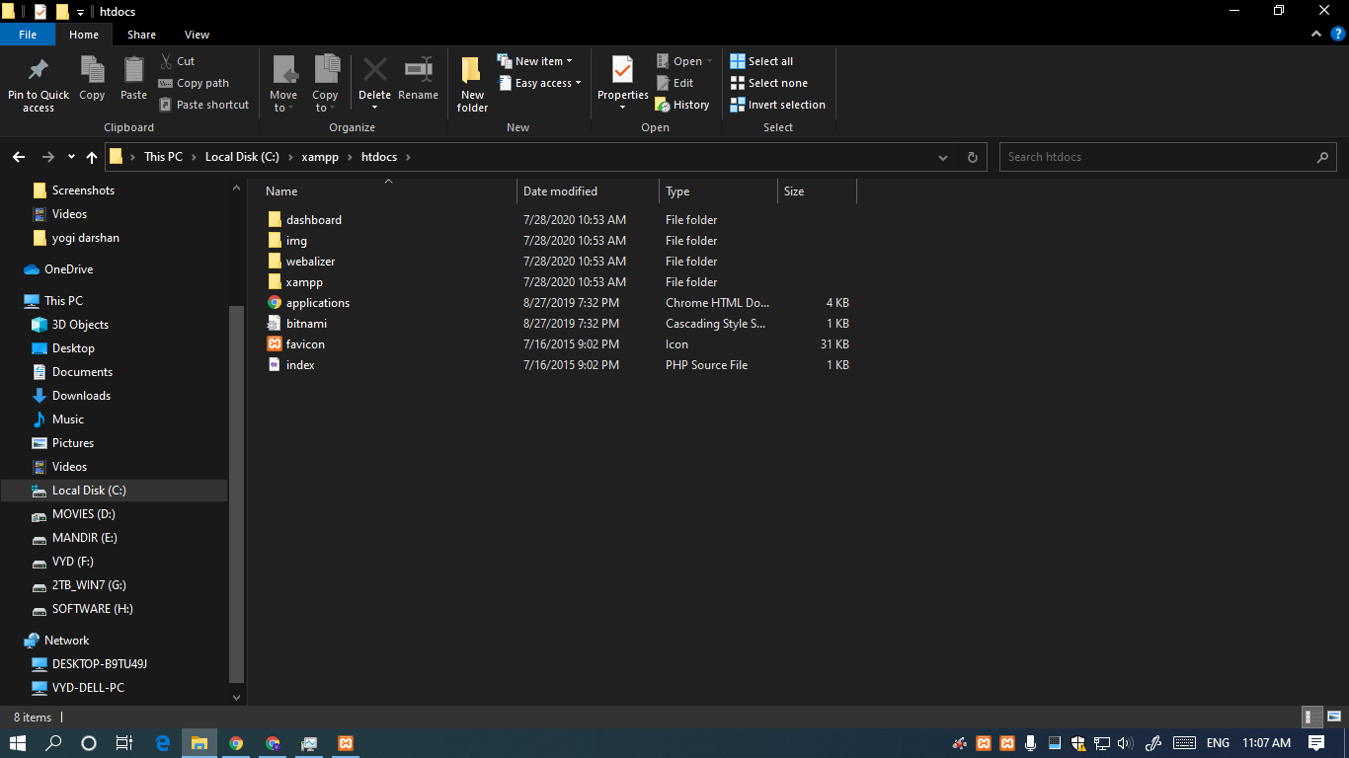

**STEP 11**

DELETE ALL FILES AND PASTE YOUR OWN PROJECT FILES IN THIS DIRECTORY AND USE THIS AS ROOT DIRECTORY

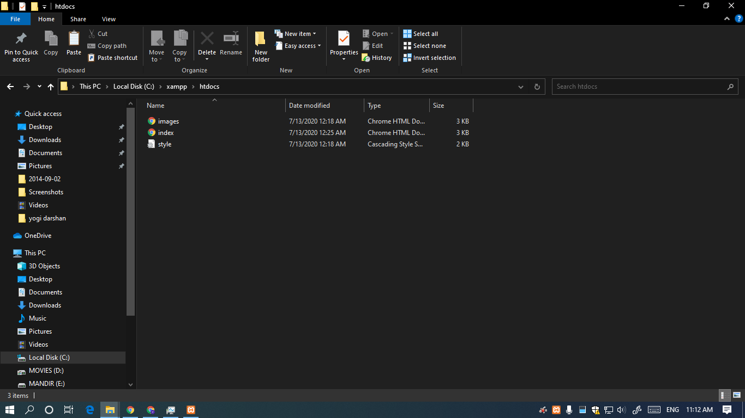

**STEP 12**

NOW OPEN YOUR BROWSER AND TYPE localhost IN URL TAB

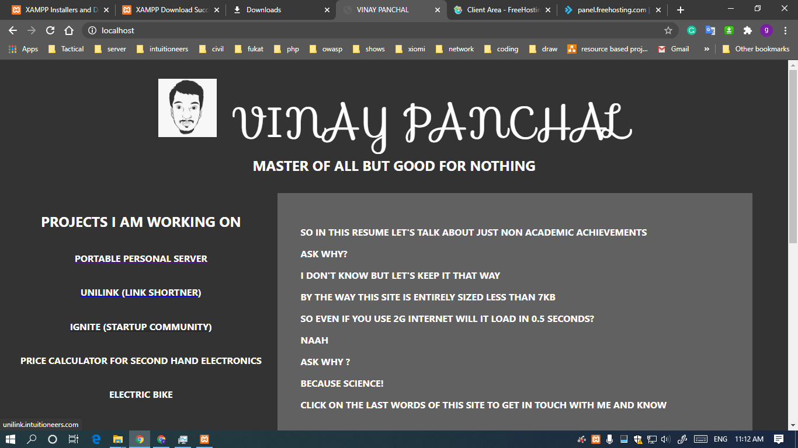

**STEPS TO RUN A .HTML FILE USING LAMP/XAMP/WAMP SERVER**

1. Go to "Start" on the Windows taskbar and type "XAMPP" into the search box. Select "XAMPP Control Panel" and press the "Enter" key. Start Apache from the XAMPP Control Panel. Apache is ready for use once you see the word "Running" highlighted in green.

1. Go to "Start" and open "Computer." Navigate to your XAMPP folder, normally found as a top-level folder under your computer's main hard drive. Open the htdocs folder.

1. Open "Computer" again and navigate to the folder where you keep your HTML files. If you do not already have any HTML files created, create one and save it to the htdocs folder under the XAMPP folder. Copy and paste your HTML files, if you find any, in to the htdocs folder.
2. Start your Web browser and type "localhost/filename.html" into the address bar. Press "Enter" and watch your HTML file load as a Web page. Now your Apache server that came with XAMPP is serving your Web pages.

**SOURCE CODE OF ENTIRE EXPERIMENT ON**

<https://github.com/vinaynpp/wdl>

**CONCLUSION :** SO WE FINALLY ACHIEVED WHAT WE WANTED

**Experiment 2**

# **AIM:** Create a detailed resume, provide links for all your social media accounts . Use tables ,frames, hyper links in designing your detailed resume

**THEORY:**

**HTML**

HTML is the standard markup language for creating Web pages.

HTML stands for Hyper Text Markup Language

HTML is the standard markup language for creating Web pages

HTML describes the structure of a Web page

HTML consists of a series of elements

HTML elements tell the browser how to display the content

HTML elements label pieces of content such as "this is a heading", "this is a paragraph", "this is a link", etc.

All HTML documents must start with a document type declaration: <!DOCTYPE html>.

The HTML document itself begins with <html> and ends with </html>.

The visible part of the HTML document is between <body> and </body>

**The <!DOCTYPE> Declaration**

The <!DOCTYPE> declaration represents the document type, and helps browsers to display web pages correctly.

It must only appear once, at the top of the page (before any HTML tags).

The <!DOCTYPE> declaration is not case sensitive.

The <!DOCTYPE> declaration for HTML5 is:

<!DOCTYPE html>

**HTML Headings**

HTML headings are defined with the <h1> to <h6> tags.

<h1> defines the most important heading. <h6> defines the least important heading:

Example

<h1>This is heading 1</h1>

<h2>This is heading 2</h2>

<h3>This is heading 3</h3>

**HTML Paragraphs**

HTML paragraphs are defined with the <p> tag:

Example

<p>This is a paragraph.</p>

<p>This is another paragraph.</p>

**HTML Links**

HTML links are defined with the <a> tag:

Example

<a href="https://www.pinterest.com">This is a link</a>

The link's destination is specified in the href attribute.

Attributes are used to provide additional information about HTML elements.

**HTML Images**

HTML images are defined with the <img> tag.

The source file (src), alternative text (alt), width, and height are provided as attributes:

Example

<img src="car.jpg" alt="cars.com" width="104" height="142">

**PROGRAM:**

**Speciality of this code**

Entire site is made from scratch with zero binary files hosted….

All images are remotely loaded directly from Google drive as thumbnails.

Hence increasing performance on web hosting by dividing load with free Google drive hosting.

**INDEX FILE HTML PART**

<!DOCTYPE html>

<html lang="en">

<head>

    <title>VINAY PANCHAL</title>

    <link rel="stylesheet" href="style.css">

    <link rel="stylesheet" href="https://fonts.googleapis.com/css?family=Sofia">

    <meta name="viewport" content="width=device-width, initial-scale=1.0">

</head>

<body>

    <header>

        <main><img src="https://drive.google.com/thumbnail?id=1PMrBo42GXpToOfdkrbTVgIz9MyqRGOiA" alt="my face"

                style="width:100px;height:100px;">

            VINAY PANCHAL </main>

        </a>

    </header>

    <h4>

        MASTER OF ALL BUT GOOD FOR NOTHING

    </h4>

    <section>

        <div class="aaju">

            <h4>

                projects i am working on

            </h4>

            <a href="http://www.vinaypanchal.com/projects/projects.html">

                <h6>portable personal server</h6>

            </a>

            <a href="http://unilink.intuitioneers.com/">

                <h6>unilink (link shortner)</h6>

            </a>

            <a href="http://intuitioneers.com/">

                <h6>ignite (startup community)</h6>

            </a>

            <a href="http://www.vinaypanchal.com/projects/projects.html">

                <h6>price calculator for second hand electronics</h6>

            </a>

            <a href="http://www.vinaypanchal.com/projects/projects.html">

                <h6>electric bike</h6>

            </a>

        </div>

        <div class="baaju">

            <h3>

                so in this resume let's talk about just non academic achievements

            </h3>

            <h3>

                ask why?

            </h3>

            <h3>

                i don't know but let's keep it that way

            </h3>

            <h3>

                by the way this site is entirely sized less than 7kb

            </h3>

            <h3>

                so even if you use 2g internet will it load in 0.5 seconds?

            </h3>

            <h3>

                naah

            </h3>

            <h3>

                ask why ?

            </h3>

            <h3>

                because science!

            </h3>

            <h3>

                click on the last words of this site to get in touch with me and know

            </h3>

        </div>

    </section>

    <div>

        <a href="images.html">

            <h4><br>checkout my photography skills</h4>

        </a>

        <a href="https://youtu.be/sbXfAQ5utWs">

            <h4>artistic schientist(youtube channel)</h4>

        </a>

        <a href="https://youtu.be/fPR5xxxjnWM">

            <h4>keen psyche(youtube channel)</h4>

        </a>

        <a href="https://github.com/vinaynpp">

            <h4>my github repos</h4>

        </a>

        <a href="winmod.html">

            <h4>WINMOD PROJECT <br> MODIFIED VERSIONS OF WINDOWS MADE BY ME</h4>

        </a>

    </div>

    <section>

        <footer>

            <a href="https://yaadnahiabhi.typeform.com/to/qa39Iv">

                <h6>GOT SOMETHING TO SAY ?</h6>

            </a>

        </footer>

    </section>

</body>

</html>

**INDEX FILE CSS PART**

body {

    background-color: #333333;

    font: 16px 'Indie Flower';

    width: 90%;

    padding: 4.5%;

}

main {

    color: #ffffff;

    text-align: center;

    float: right;

    text-transform: uppercase;

    font-family: "Sofia";

    font-size: 450%;

    width: 100%;

}

h6 {

    color: #ffffff;

    text-align: center;

    text-transform: uppercase;

    font-family: 'Segoe UI', sans-serif;

    font-size: 100%;

}

H5 {

    color: #ffffff;

    text-align: center;

    text-transform: uppercase;

    font-family: 'Segoe UI', sans-serif;

    font-size: 300%;

}

h4 {

    color: #ffffff;

    text-align: center;

    text-transform: uppercase;

    font-family: 'Segoe UI', sans-serif;

    font-size: 150%;

}

h3 {

    color: #ffffff;

    text-align: left;

    text-transform: uppercase;

    font-family: 'Segoe UI', sans-serif;

    font-size: 100%;

}

p {

    color: #ffffff;

    text-transform: uppercase;

    font-family: 'Segoe UI', sans-serif;

    font-size: 100%;

}

.center {

    display: block;

    margin-left: auto;

    margin-right: auto;

    width: 75%;

}

.aaju {

    width: 35%;

    float: left;

}

.baaju {

    width: 55%;

    float: left;

    background-color: #616161;

    padding: 3%;

}

table {

    background-color: #ffffff;

    width: 100%;

    padding: 20px;

    border: 40px #333333;

    border-spacing: 10px;

    border-color: black;

}

td {

    text-align: center;

    padding: 20px;

    border: 40px #333333;

    border-spacing: 10px;

    border-color: black;

    font-family: 'Segoe UI', sans-serif;

}

caption {

    font-family: "Sofia";

    font-size: xx-large;

    color: #ffffff;

}

footer {

    float: bottom;

    text-align: center;

    padding: 10% 10%;

}

**SOURCE CODE OF ENTIRE EXPERIMENT ON**

<https://github.com/vinaynpp/wdl>

**OUTPUT:**



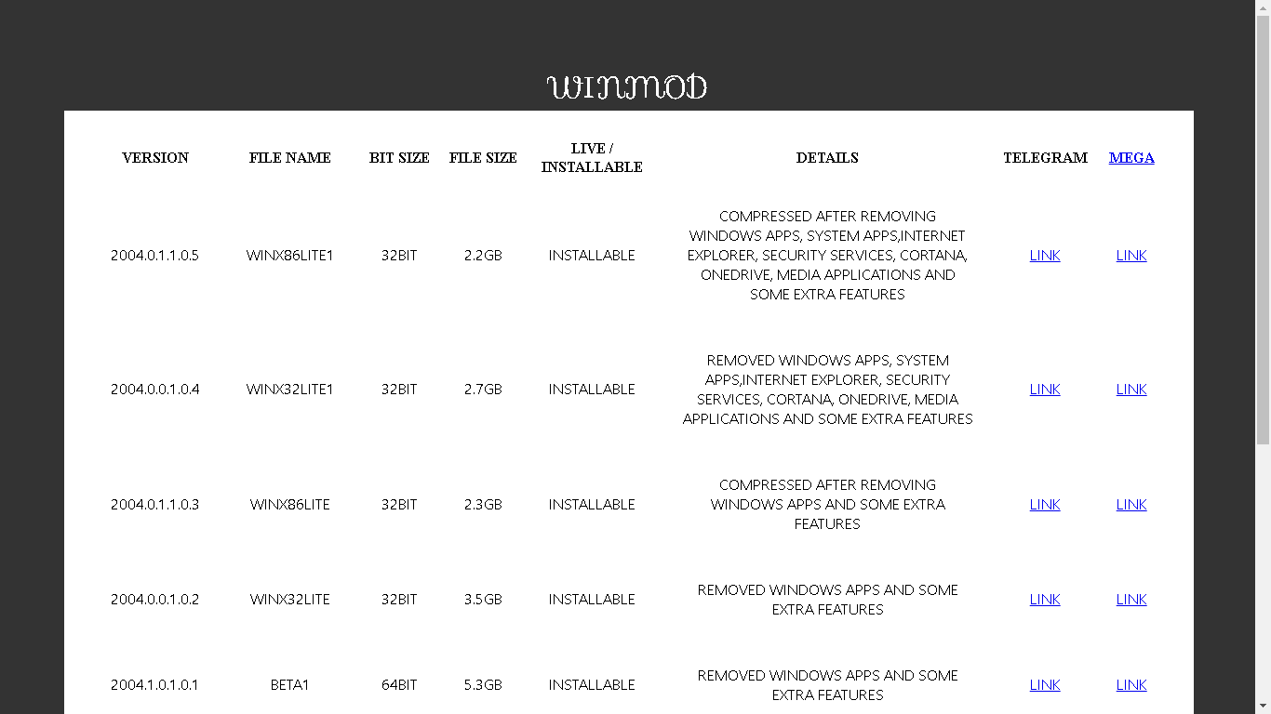

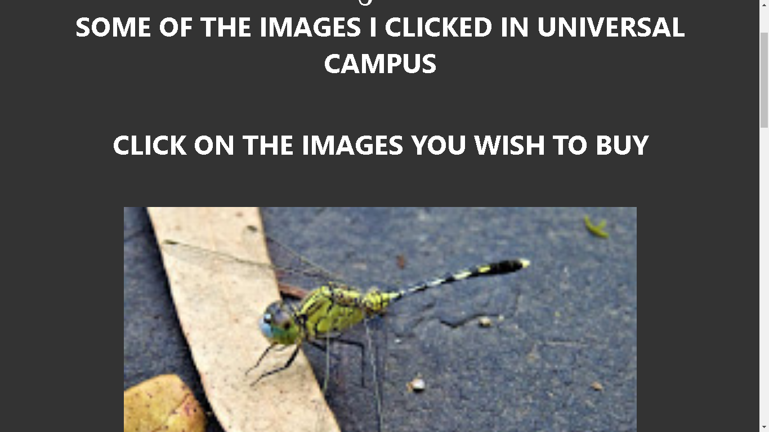

**CONCLUSION**

# Hence we have created a detailed resume, provide links for all our social media accounts . Using tables ,frames, hyper links in designing our detailed resume.

**Experiment 3**

# **AIM:** Create a e-commerce website by using HTML, CSS and JAVA SCRIPT

**THEORY:**

**CSS**

CSS stands for Cascading Style Sheets

CSS describes how HTML elements are to be displayed on screen, paper, or in other media

CSS saves a lot of work. It can control the layout of multiple web pages all at once

External stylesheets are stored in CSS files

A CSS rule-set consists of a selector and a declaration block:

The selector points to the HTML element you want to style.

The declaration block contains one or more declarations separated by semicolons.

Each declaration includes a CSS property name and a value, separated by a colon.

Multiple CSS declarations are separated with semicolons, and declaration blocks are surrounded by curly braces.

**JavaScript**

JavaScript is the world's most popular programming language.

JavaScript is the programming language of the Web.

JavaScript is easy to learn.

This tutorial will teach you JavaScript from basic to advanced.

**PROGRAM:**

**INDEX FILE HTML PART**

<?php require('upar.php') ?>

<?php

$get_product = get_product($con, 4);

foreach ($get_product as $list) {

?>

    <div class="bich">

        <div class="dabba">

            <h4><br><br></h4>

            <img src="<?php echo PRODUCT_IMAGE_SITE_PATH . $list['image'] ?>" alt="product images">

            <h5><?php echo $list['name'] ?></h5>

            <ul>

                <li>

                    <H4><?php echo "ORIGINAL BHAAV : ₹";

                        echo  $list['mrp'] ?></H4>

                </li>

                <li>

                    <H3><?php echo "STOCK BAAKI : ";

                        echo $list['qty'] ?></H3>

                </li>

                <H3><?php echo "DETAIL : ";

                    echo $list['description'] ?></H3>

                <h4><br><br></h4>

        </div>

    <?php } ?>

    </div>

    <?php require('niche.php') ?>

**ENTIRE PROJECT CSS PART**

body {

    background-color: #FFE0B2;

    font: 16px 'Indie Flower';

}

main {

    color: #d50000;

    text-align: center;

    float: right;

    text-transform: uppercase;

    font-family: "Sofia";

    font-size: 450%;

    width: 100%;

}

h3 {

    color: #2962FF;

    text-align: center;

    text-transform: uppercase;

    font-family: 'Segoe UI', sans-serif;

    font-size: 100%;

    padding-right: 10%;

    padding-left: 8%;

}

H5 {

    color: #d50000;

    text-align: center;

    text-transform: uppercase;

    font-family: 'Segoe UI', sans-serif;

    font-size: 300%;

}

h4 {

    color: #ffffff;

    text-align: center;

    text-transform: uppercase;

    font-family: 'Segoe UI', sans-serif;

    font-size: 150%;

}

h6 {

    color: #2962FF;

    text-align: center;

    text-transform: uppercase;

    font-family: 'Segoe UI', sans-serif;

    font-size: 300%;

}

p {

    font-family: 'Segoe UI', sans-serif;

    font-size: 100%;

}

ul {

    list-style: none;

}

.center {

    display: block;

    margin-left: auto;

    margin-right: auto;

    width: 75%;

}

.aaju {

    width: 35%;

    float: left;

}

.baaju {

    width: 55%;

    float: left;

    background-color: #616161;

    padding: 3%;

}

.bich {

    text-align: center;

}

.dabba {

    background-color: rgb(42, 44, 46);

    width: 75%;

    margin: auto;

    border: antiquewhite;

    float: inline-start;

    border-radius: 25%;

    text-align: center;

}

table {

    background-color: #ffffff;

    width: 100%;

    padding: 20px;

    border: 40px #333333;

    border-spacing: 10px;

    border-color: black;

}

td {

    text-align: center;

    padding: 20px;

    border: 40px #333333;

    border-spacing: 10px;

    border-color: black;

    font-family: 'Segoe UI', sans-serif;

}

caption {

    font-family: "Sofia";

    font-size: xx-large;

    color: #ffffff;

}

footer {

    float: bottom;

    text-align: center;

    padding: 10% 10%;

}

**SOURCE CODE OF ENTIRE EXPERIMENT ON**

<https://github.com/vinaynpp/wdl>

**OUTPUT:**



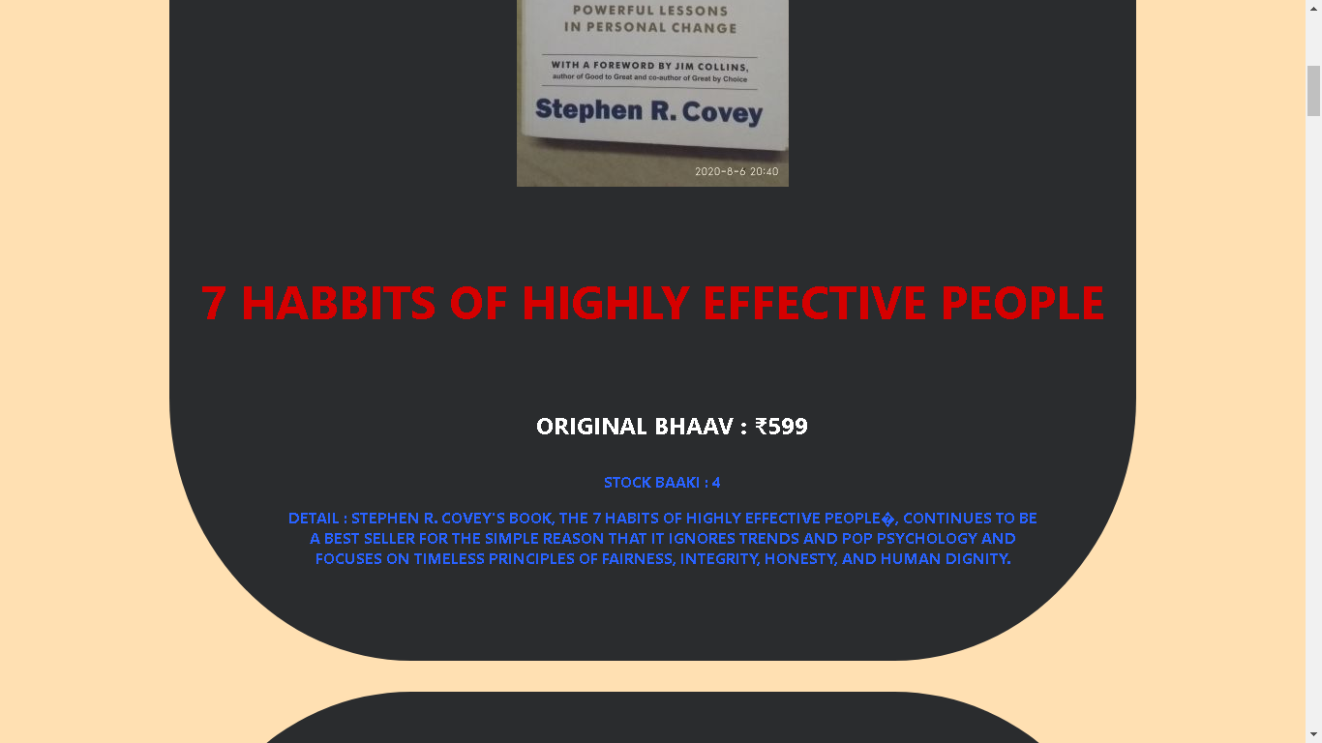



**CONCLUSION**

# Successfully created a e-commerce website by using HTML, CSS and JAVA SCRIPT

**Experiment 4**

# **AIM:** Using PhP and mysql perform the following operations 1. Create 2. Read 3.Update 4. Delete

**THEORY:**

CRUD is an acronym for **C**reate, **R**ead, **U**pdate, and **D**elete. CRUD operations are basic data manipulation for database

**PHP**

PHP is an acronym for "PHP: Hypertext Preprocessor"

PHP is a widely-used, open source scripting language

PHP scripts are executed on the server

PHP is free to download and use

PHP can generate dynamic page content

PHP can create, open, read, write, delete, and close files on the server

PHP can collect form data

PHP can send and receive cookies

PHP can add, delete, modify data in your database

PHP can be used to control user-access

PHP can encrypt data

PHP script can be placed anywhere in the document.

A PHP script starts with <?php and ends with ?>:

The default file extension for PHP files is ".php".

A PHP file normally contains HTML tags, and some PHP scripting code

**MYSQL**

MySQL provides a set of some basic but most essential operations that will help you to easily interact with the MySQL database

Some of The Most Important SQL Commands

SELECT - extracts data from a database

UPDATE - updates data in a database

DELETE - deletes data from a database

INSERT INTO - inserts new data into a database

CREATE DATABASE - creates a new database

ALTER DATABASE - modifies a database

CREATE TABLE - creates a new table

ALTER TABLE - modifies a table

DROP TABLE - deletes a table

CREATE INDEX - creates an index (search key)

DROP INDEX - deletes an index

**PROGRAM:**

**SQL CONNECTIVITY PART**

<?php

session_start();

$con = mysqli_connect("localhost", "root", "", "ecom");

define('SERVER_PATH', $_SERVER['DOCUMENT_ROOT'] . '/ecom1/');

define('SITE_PATH', 'http://localhost/ecom1/');

define('PRODUCT_IMAGE_SITE_PATH', SITE_PATH . 'photu/');

define('PRODUCT_IMAGE_SERVER_PATH', SERVER_PATH . 'photu/');

?>

**FUNCTIONS PART**

<?php

function pr($arr){

    echo '<pre>';

    print_r($arr);

}

function prx($arr){

    echo '<pre>';

    print_r($arr);

    die();

}

function get_safe_value($con, $str)

{

    if ($str != '') {

        $str = trim($str);

        return mysqli_real_escape_string($con, $str);

    }

}

function get_product($con,$limit='',$product_id='',$cat_id=''){

    $sql="select * from product ";

    if($product_id!=''){

        $sql.=" where product.id=$product_id ";

    }

    if($limit!=''){

        $sql.=" limit $limit";

    }

    $res=mysqli_query($con,$sql);

    $data=array();

    while($row=mysqli_fetch_assoc($res)){

        $data[]=$row;

    }

    return $data;

}

?>

**ADMIN DASHBOARD PART**

<?php

require('connection.inc.php');

require('functions.inc.php');

if (isset($_SESSION['ADMIN_LOGIN']) && $_SESSION['ADMIN_LOGIN'] != '') {

} else {

    header('location:bossandar.php');

    die();

}

if (isset($_GET['type']) && $_GET['type'] != '') {

    $type = get_safe_value($con, $_GET['type']);

    if ($type == 'status') {

        $operation = get_safe_value($con, $_GET['operation']);

        $id = get_safe_value($con, $_GET['id']);

        if ($operation == 'active') {

            $status = '1';

        } else {

            $status = '0';

        }

        $update_status_sql = "update product set status='$status' where id='$id'";

        mysqli_query($con, $update_status_sql);

    }

    if ($type == 'delete') {

        $id = get_safe_value($con, $_GET['id']);

        $delete_sql = "delete from product where id='$id'";

        mysqli_query($con, $delete_sql);

    }

}

$sql = "select product.* from product order by product.id desc";

$res = mysqli_query($con, $sql);

?>

<?php require('bossnav.php');?>

    <table style="width: 100%;">

        <tr>

            <th>IMAGES</th>

            <th>TITLE</th>

            <th>MRP</th>

            <th>STOCK</th>

            <th>DETAIL</th>

            <th>ACTIVATION</th>

            <th>EDIT</th>

            <th>DELETE</th>

        </tr><?php

                $i = 1;

                while ($row = mysqli_fetch_assoc($res)) {

                ?><tr>

                <td><img src="<?php echo PRODUCT_IMAGE_SITE_PATH . $row['image'] ?>" alt="product images" style="width: 60px;"></td>

                <td>

                    <h5><?php echo $row['name'] ?></h5>

                </td>

                <td>

                    <H4><?php echo "₹";

                        echo  $row['mrp'] ?></H4>

                </td>

                <td><?php echo $row['qty'] ?></td>

                <td style="width: 30%;"><?php echo "DETAIL : ";

                                        echo $row['description'] ?></td>

                <td><?php if ($row['status'] == 1) {

                        echo "<span ><a href='?type=status&operation=deactive&id=" . $row['id'] . "'>Active</a></span>&nbsp;";

                    } else {

                        echo "<span ><a href='?type=status&operation=active&id=" . $row['id'] . "'>Deactive</a></span>&nbsp;";

                    }           ?></td>

                <td><?php

                    echo "<span ><a href='product.php?id=" . $row['id'] . "'>Edit</a></span>&nbsp;";

                    ?></td>

                <td><?php

                    echo "<span ><a href='?type=delete&id=" . $row['id'] . "'>Delete</a></span>";

                    ?></td>

                <td></td>

            </tr><?php } ?>

    </table>

    <div class="footer">

        <p>Copyright© <a href="http://vinaypanchal.com/">VINAY PANCHAL</a>All right reserved.</p>

    </div>

    <script src="bs.js"></script>

</body>

</html>

**PRODUCT EDIT PART**

<?php

require('connection.inc.php');

require('functions.inc.php');

$name = '';

$mrp = '';

$qty = '';

$image = '';

$description    = '';

$msg = '';

$image_required = 'required';

if (isset($_GET['id']) && $_GET['id'] != '') {

    $image_required = '';

    $id = get_safe_value($con, $_GET['id']);

    $res = mysqli_query($con, "select * from product where id='$id'");

    $check = mysqli_num_rows($res);

    if ($check > 0) {

        $row = mysqli_fetch_assoc($res);

        $name = $row['name'];

        $mrp = $row['mrp'];

        $qty = $row['qty'];

        $description = $row['description'];

    } else {

        header('location:index.php');

        die();

    }

}

if (isset($_POST['submit'])) {

    $name = get_safe_value($con, $_POST['name']);

    $mrp = get_safe_value($con, $_POST['mrp']);

    $qty = get_safe_value($con, $_POST['qty']);

    $description = get_safe_value($con, $_POST['description']);

    $res = mysqli_query($con, "select * from product where name='$name'");

    $check = mysqli_num_rows($res);

    if ($check > 0) {

        if (isset($_GET['id']) && $_GET['id'] != '') {

            $getData = mysqli_fetch_assoc($res);

            if ($id == $getData['id']) {

            } else {

                $msg = "Product already exist";

            }

        } else {

            $msg = "Product already exist";

        }

    }

    if ($_GET['id'] == 0) {

        if ($_FILES['file']['type'] != 'image/png' && $_FILES['image']['type'] != 'image/jpg' && $_FILES['file']['type'] != 'image/jpeg') {

            $msg = "Please select only png,jpg and jpeg image formate";

        }

    } else {

        if ($_FILES['file']['type'] != '') {

            if ($_FILES['file']['type'] != 'image/png' && $_FILES['image']['type'] != 'image/jpg' && $_FILES['file']['type'] != 'image/jpeg') {

                $msg = "Please select only png,jpg and jpeg image formate";

            }

        }

    }

    if ($msg == '') {

        if (isset($_GET['id']) && $_GET['id'] != '') {

            if ($_FILES['image']['name'] != '') {

                $image=rand(111111111,999999999).'_'.$_FILES['image']['name'];

                move_uploaded_file($_FILES['image']['tmp_name'],PRODUCT_IMAGE_SERVER_PATH.$image);

                $update_sql = "update product set name='$name',mrp='$mrp',qty='$qty',description='$description',image='$image' where id='$id'";

            } else {

                $update_sql = "update product set name='$name',mrp='$mrp',qty='$qty',description='$description' where id='$id'";

            }

            mysqli_query($con, $update_sql);

        } else {

            $image=rand(111111111,999999999).'_'.$_FILES['image']['name'];

            move_uploaded_file($_FILES['image']['tmp_name'],PRODUCT_IMAGE_SERVER_PATH.$image);

            mysqli_query($con, "insert into product(name,mrp,qty,description,status,image) values('$name','$mrp','$qty','$description',1,'$image')");

        }

        header('location:index.php');

        die();

    }

}

?>

**SOURCE CODE OF ENTIRE EXPERIMENT ON**

<https://github.com/vinaynpp/wdl>

**OUTPUT:**

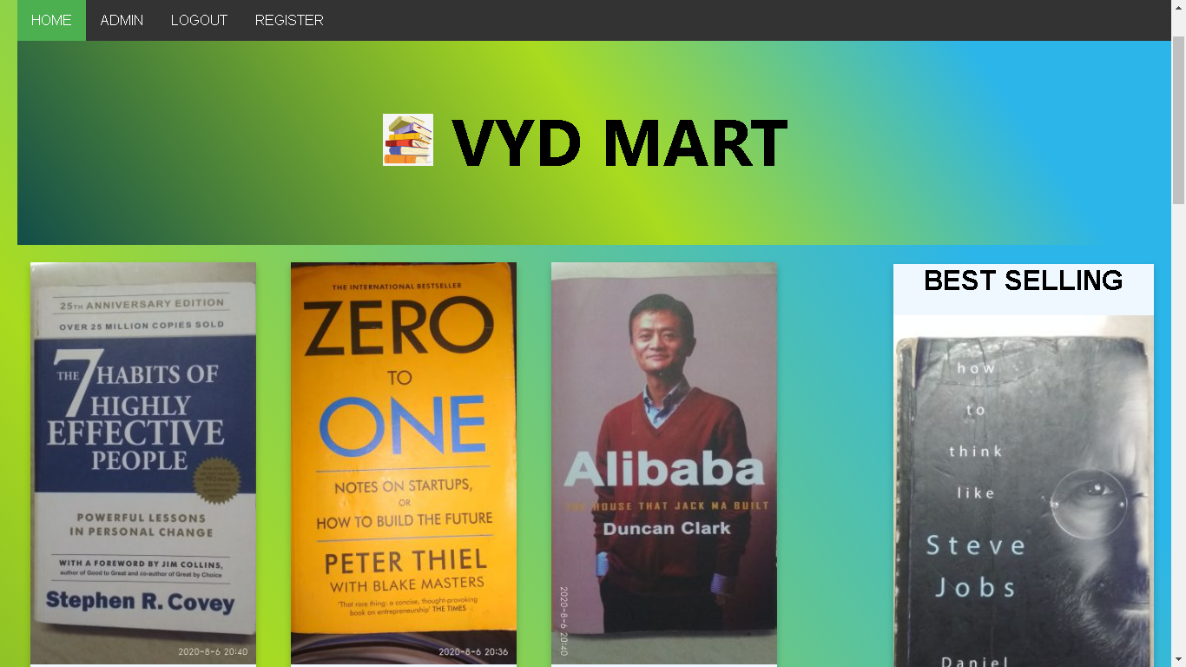

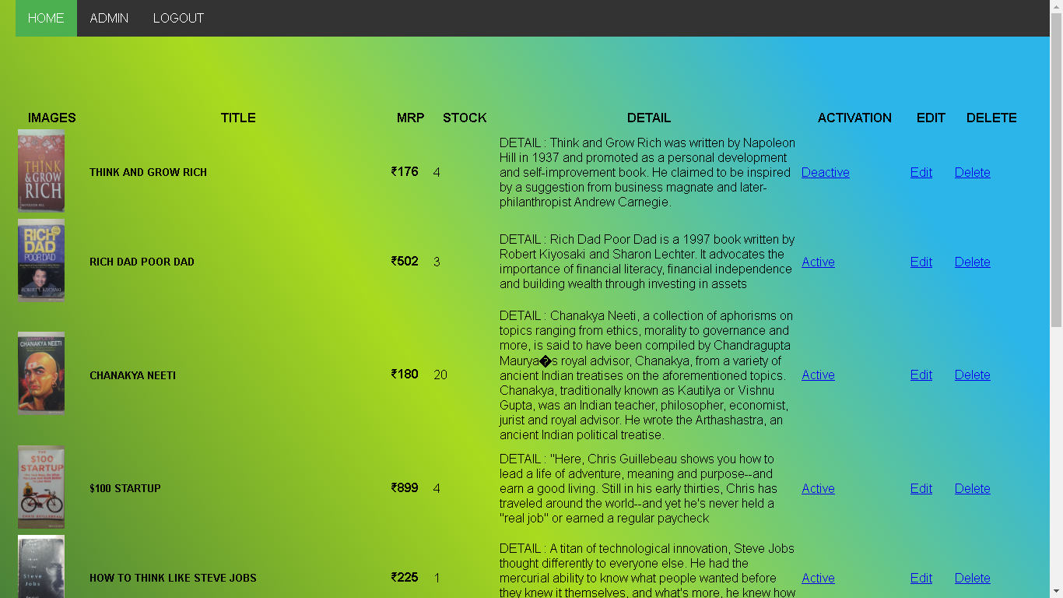

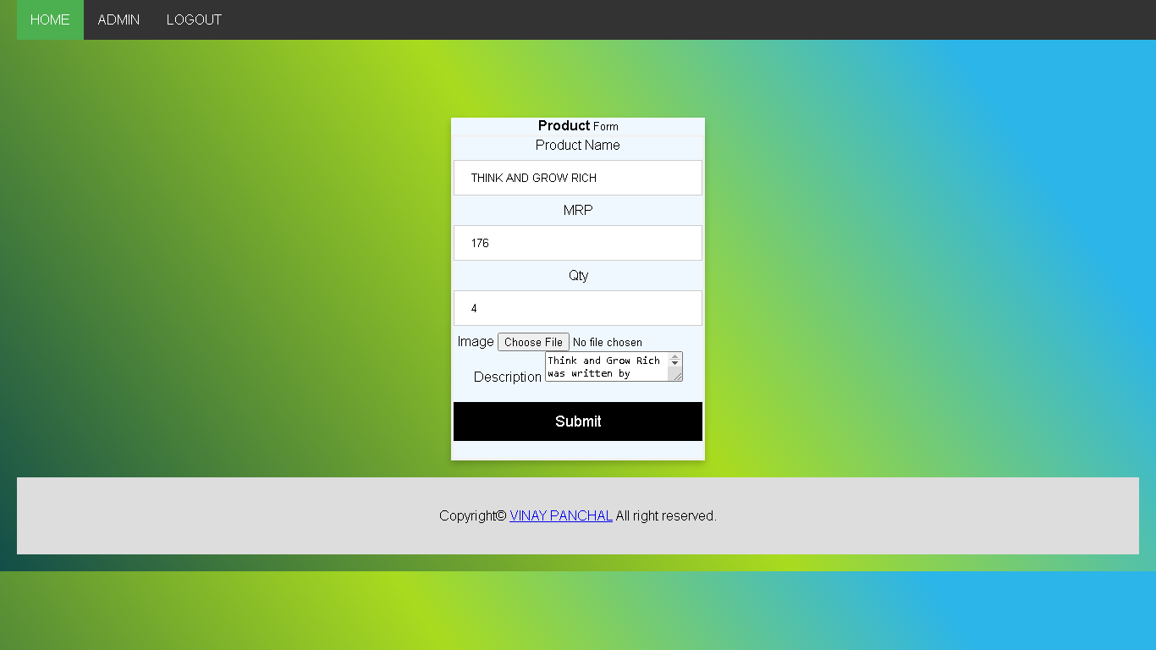

**CONCLUSION**

Thus, implemented CRUD operations using PHP and MySQL.

**Experiment 5**

# **AIM:** Using php and mysql develop a fully functional login and registration form. Add features such as forgot password and password matching

**THEORY:**

**HTML F** **ORMS**

An HTML form is used to collect user input. The user input is most often sent to a server for processing

The <form> Element

The HTML <form> element is used to create an HTML form for user input:

The <form> element is a container for different types of input elements, such as: text fields, checkboxes, radio buttons, submit buttons, etc.

The <input> Element

The HTML <input> element is the most used form element.

An <input> element can be displayed in many ways, depending on the type attribute.

Here are some examples:

Type Description

<input type="text"> Displays a single-line text input field

<input type="radio"> Displays a radio button (for selecting one of many choices)

<input type="checkbox"> Displays a checkbox (for selecting zero or more of many choices)

<input type="submit"> Displays a submit button (for submitting the form)

<input type="button"> Displays a clickable button

The <label> Element

The <label> tag defines a label for many form elements.

The <label> element is useful for screen-reader users, because the screen-reader will read out loud the label when the user focus on the input element.

The <label> element also help users who have difficulty clicking on very small regions (such as radio buttons or checkboxes) - because when the user clicks the text within the <label> element, it toggles the radio button/checkbox.

The for attribute of the <label> tag should be equal to the id attribute of the <input> element to bind them together.

Radio Buttons

The <input type="radio"> defines a radio button.

Radio buttons let a user select ONE of a limited number of choices.

Checkboxes

The <input type="checkbox"> defines a checkbox.

Checkboxes let a user select ZERO or MORE options of a limited number of choices.

The Submit Button

The <input type="submit"> defines a button for submitting the form data to a form-handler.

The form-handler is typically a file on the server with a script for processing input data.

The form-handler is specified in the form's action attribute.

The Name Attribute for <input>

Notice that each input field must have a name attribute to be submitted.

If the name attribute is omitted, the value of the input field will not be sent at all.

**PHP**

PHP is an acronym for "PHP: Hypertext Preprocessor"

PHP is a widely-used, open source scripting language

PHP scripts are executed on the server

PHP is free to download and use

PHP can generate dynamic page content

PHP can create, open, read, write, delete, and close files on the server

PHP can collect form data

PHP can send and receive cookies

PHP can add, delete, modify data in your database

PHP can be used to control user-access

PHP can encrypt data

PHP script can be placed anywhere in the document.

A PHP script starts with <?php and ends with ?>:

The default file extension for PHP files is ".php".

A PHP file normally contains HTML tags, and some PHP scripting code

**MYSQL**

MySQL provides a set of some basic but most essential operations that will help you to easily interact with the MySQL database

Some of The Most Important SQL Commands

SELECT - extracts data from a database

UPDATE - updates data in a database

DELETE - deletes data from a database

INSERT INTO - inserts new data into a database

CREATE DATABASE - creates a new database

ALTER DATABASE - modifies a database

CREATE TABLE - creates a new table

ALTER TABLE - modifies a table

DROP TABLE - deletes a table

CREATE INDEX - creates an index (search key)

DROP INDEX - deletes an index

**PROGRAM:**

**USER REGISTERATION PART**

<?php

require('boss/connection.inc.php');

require('boss/functions.inc.php');

$msg = "";

if (isset($_POST['submit'])) {

    $username = get_safe_value($con, $_POST['username']);

      $email = get_safe_value($con, $_POST['email']);

    $password = get_safe_value($con, $_POST['password']);

    $check_user=mysqli_num_rows(mysqli_query($con,"select * from users where username='$username'"));

    if($check_user>0){

        $msg = "username already exists";

    }else{

        $sql = "INSERT INTO `users` (`id`, `username`, `password`, `email`) VALUES (NULL, '$username', '$password', '$email')";

        mysqli_query($con,$sql);

        echo "insert";

        $_SESSION['USER_LOGIN'] = 'yes';

        $_SESSION['USER_USERNAME'] = $username;

        header('location:index.php');

        die();

    }

}

?>

<?php require('nav.php'); ?>

<div class="card">

    <div class="andar">

        <form method="post">

            <div class="imgcontainer">

                <img src="vinay.jpg" alt="Avatar" class="avatar">

            </div>

            <div class="container">

                <div>

                    <label for="username">

                        <h3>

                            USERNAME

                        </h3>

                    </label>

                    <input type="text" name="username" id="" placeholder="username" required>

                </div>

                <div>

                    <label for="email">

                        <h3>

                            EMAIL

                        </h3>

                    </label>

                    <input type="email" name="email" id="" placeholder="email" required>

                </div>

                <div>

                    <label for="password">

                        <h3>

                            PASSWORD

                        </h3>

                    </label>

                    <input type="password" name="password" id="" placeholder="password" required>

                </div>

                <div>

                    <button type="submit" name="submit">

                        <h4>

                            REGISTER

                        </h4>

                    </button>

                    <?php echo $msg ?>

                </div>

            </div>

        </form>

    </div>

</div>

<div class="footer">

   <p>Copyright© <a href="http://vinaypanchal.com/">VINAY PANCHAL</a> All right reserved.</p>

</div>

</body>

</html>

**USER LOGIN PART**

<?php

require('boss/connection.inc.php');

require('boss/functions.inc.php');

$msg="";

if(isset($_POST['submit'])){

    $username=get_safe_value($con,$_POST['username']);

    $password=get_safe_value($con,$_POST['password']);

    $sql="select * from users where username='$username' and password='$password'";

    $res=mysqli_query($con,$sql);

    $count=mysqli_num_rows($res);

    if($count>0){

        $_SESSION['USER_LOGIN']='yes';

        $_SESSION['USER_USERNAME']=$username;

        header('location:index.php');

        die();

    }else{

        $msg="Please enter correct login details";

    }

}

?>

<?php require('nav.php');?>

    <div class="card" >

    <div class="andar">

        <form  method="post">

            <div class="imgcontainer">

                <img src="vinay.jpg" alt="Avatar" class="avatar">

            </div>

            <div class="container">

                <div>

                    <label for="username">

                        <h1>

                            USERNAME

                        </h1>

                    </label>

                    <input type="text" name="username" id="" placeholder="username" required>

                </div>

                <div>

                    <label for="password">

                        <h1>

                            PASSWORD

                        </h1>

                    </label>

                    <input type="password" name="password" id="" placeholder="password" required>

                </div>

                <div>

                    <button type="submit" name="submit">

                        <h2>

                            SIGN IN

                        </h2>

                    </button>

                    <?php echo $msg?>

                </div>

                <div>

                <h4 > <a href="forgetpassword.php">forgot password?</a>

                </h4>

                </div>

            </div>

        </form>

    </div>

    </div>

    <div class="footer">

        <p>Copyright© <a href="http://vinaypanchal.com/">VINAY PANCHAL</a> All right reserved.</p>

    </div>

</body>

</html>

**USER FORGOT PASSWORD PART**

<?php

require('boss/connection.inc.php');

require('boss/functions.inc.php');

$msg = "";

if (isset($_POST['submit'])) {

   $email = get_safe_value($con, $_POST['email']);

   $sql = "select * from users where email='$email' ";

   $res = mysqli_query($con, $sql);

   $count = mysqli_num_rows($res);

   if ($count > 0) {

      $sql = " SELECT USERNAME FROM `users` WHERE `email`= '$email'";

      $res = mysqli_query($con, $sql);

      $arrr = mysqli_fetch_array($res);

      $username = $arrr['USERNAME'];

      $sql = " SELECT PASSWORD FROM `users` WHERE `email`= '$email'";

      $res = mysqli_query($con, $sql);

      $arrr = mysqli_fetch_array($res);

      $password = $arrr['PASSWORD'];

      $html = "<table><tr><td>username</td><td>$username</td></tr><tr><td>Email</td><td>$email</td></tr><tr><td>password</td><td>$password</td></tr</table>";

      $khudkaemail = "";

      $khudkapassword = "";

      include('smtp/PHPMailerAutoload.php');

      $mail = new PHPMailer(true);

      $mail->isSMTP();

      $mail->Host = "smtp.gmail.com";

      $mail->Port = 587;

      $mail->SMTPSecure = "tls";

      $mail->SMTPAuth = true;

      $mail->Username = $khudkaemail;

      $mail->Password = $khudkapassword;

      $mail->SetFrom($khudkaemail);

      $mail->addAddress($email);

      $mail->IsHTML(true);

      $mail->Subject = "New Contact Us";

      $mail->Body = $html;

      $mail->SMTPOptions = array('ssl' => array(

         'verify_peer' => false,

         'verify_peer_name' => false,

         'allow_self_signed' => false

      ));

      if ($mail->send()) {

         $msg = "mail has been sent";

      } else {

         $msg = "mail has not been sent";

      }

   } else {

      $msg = "Please enter correct email id";

   }

}

require('nav.php'); ?>

<div class="card">

   <div class="andar">

      <form method="post">

         <div class="imgcontainer">

            <img src="vinay.jpg" alt="Avatar" class="avatar">

         </div>

         <div class="container">

            <div>

               <label for="email">

                  <h3>

                     EMAIL

                  </h3>

               </label>

               <input type="email" name="email" id="" placeholder="email" required>

            </div>

            <button type="submit" name="submit">

               <h2>

                  submit

               </h2>

            </button>

            <?php echo $msg ?>

         </div>

   </div>

   </form>

</div>

</div>

<div class="footer">

   <p>Copyright© <a href="http://vinaypanchal.com/">VINAY PANCHAL</a> All right reserved.</p>

</div>

</body>

</html>

**SOURCE CODE OF ENTIRE EXPERIMENT ON**

<https://github.com/vinaynpp/wdl>

**OUTPUT:**

**USER REGISTERATION PART**

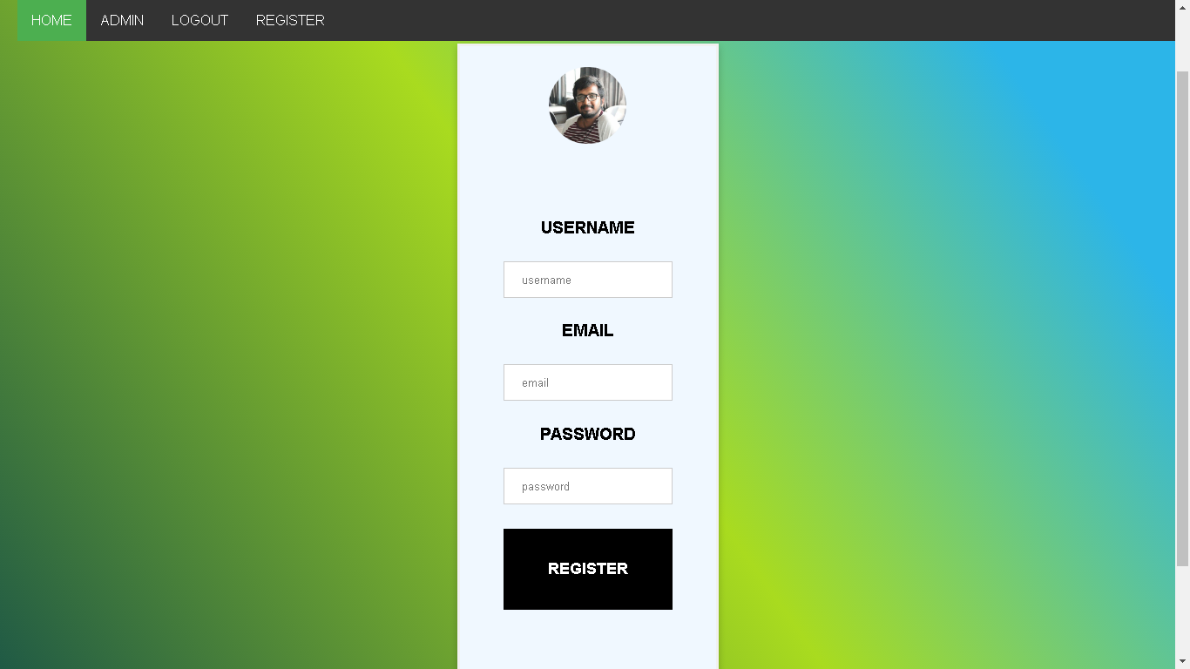

**USER LOGIN PART**

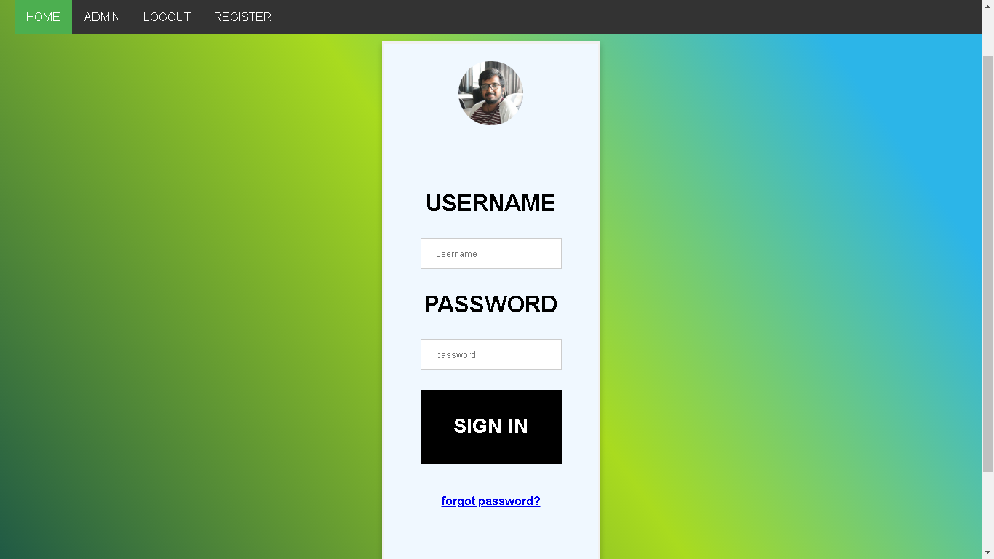

**USER FORGOT PASSWORD PART**

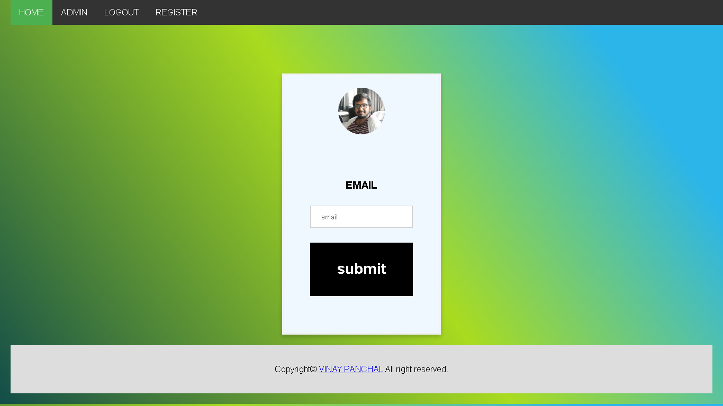

**CONCLUSION**

Thus, developed a fully functional login and registration form using PhP and mysql.

**Experiment 6**

# **AIM:** Implement search functionality using Php and ajax

**THEORY:**

**AJAX**

AJAX stands for Asynchronous JavaScript and XML. AJAX is a new technique for creating better, faster, and more interactive web applications with the help of XML, HTML, CSS and Java Script

Conventional web application transmit information to and from the sever using synchronous requests. This means you fill out a form, hit submit, and get directed to a new page with new information from the server.

With AJAX when submit is pressed, JavaScript will make a request to the server, interpret the results and update the current screen. In the purest sense, the user would never know that anything was even transmitted to the server.

**PHP**

PHP is an acronym for "PHP: Hypertext Preprocessor"

PHP is a widely-used, open source scripting language

PHP scripts are executed on the server

PHP is free to download and use

PHP can generate dynamic page content

PHP can create, open, read, write, delete, and close files on the server

PHP can collect form data

PHP can send and receive cookies

PHP can add, delete, modify data in your database

PHP can be used to control user-access

PHP can encrypt data

PHP script can be placed anywhere in the document.

A PHP script starts with <?php and ends with ?>:

The default file extension for PHP files is ".php".

A PHP file normally contains HTML tags, and some PHP scripting code

**PROGRAM:**

**LIVE SEARCH PHP PART**

<?php

$xmlDoc=new DOMDocument();

$xmlDoc->load("links.xml");

$x=$xmlDoc->getElementsByTagName('link');

//get the q parameter from URL

$q=$_GET["q"];

//lookup all links from the xml file if length of q>0

if (strlen($q)>0) {

  $hint="";

  for($i=0; $i<($x->length); $i++) {

    $y=$x->item($i)->getElementsByTagName('title');

    $z=$x->item($i)->getElementsByTagName('url');

    if ($y->item(0)->nodeType==1) {

      //find a link matching the search text

      if (stristr($y->item(0)->childNodes->item(0)->nodeValue,$q)) {

        if ($hint=="") {

          $hint="<a href='" .

          $z->item(0)->childNodes->item(0)->nodeValue .

          "' target='_blank'>" .

          $y->item(0)->childNodes->item(0)->nodeValue . "</a>";

        } else {

          $hint=$hint . "<br /><a href='" .

          $z->item(0)->childNodes->item(0)->nodeValue .

          "' target='_blank'>" .

          $y->item(0)->childNodes->item(0)->nodeValue . "</a>";

        }

      }

    }

  }

}

// Set output to "no suggestion" if no hint was found

// or to the correct values

if ($hint=="") {

  $response="no suggestion";

} else {

  $response=$hint;

}

//output the response

echo $response;

?>

**LIVE SEARCH LINK LIST PART**

<pages>

    <link>

        <title>7 HABBITS OF HIGHLY EFFECTIVE PEOPLE</title>

        <url>index.php</url>

    </link>

    <link>

        <title>ZERO TO ONE</title>

        <url>index.php</url>undefined

    </link>undefined

    <link>

        <title>ALIBABA</title>

        <url>index.php</url>undefined

    </link>undefined

    <link>

        <title>ELON MUSK</title>

        <url>index.php</url>undefined

    </link>undefined

    <link>

        <title>HOW TO THINK LIKE STEVE JOBS</title>

        <url>index.php</url>undefined

    </link>undefined

    <link>

        <title>$100 STARTUP</title>

        <url>index.php</url>undefined

    </link>undefined

    <link>

        <title>CHANAKYA NEETI</title>

        <url>index.php</url>undefined

    </link>undefined

    <link>

        <title>RICH DAD POOR DAD</title>

        <url>index.php</url>undefined

    </link>undefined

    <link>

        <title>THINK AND GROW RICH</title>

        <url>index.php</url>undefined

    </link>undefined

</pages>

**LIVE SEARCH JAVASCRIPT PART PART**

  function showResult(str) {

    if (str.length==0) {

      document.getElementById("livesearch").innerHTML="";

      document.getElementById("livesearch").style.border="0px";

      return;

    }

    var xmlhttp=new XMLHttpRequest();

    xmlhttp.onreadystatechange=function() {

      if (this.readyState==4 && this.status==200) {

        document.getElementById("livesearch").innerHTML=this.responseText;

        document.getElementById("livesearch").style.border="1px solid #A5ACB2";

      }

    }

    xmlhttp.open("GET","livesearch.php?q="+str,true);

    xmlhttp.send();

  }

**SOURCE CODE OF ENTIRE EXPERIMENT ON**

<https://github.com/vinaynpp/wdl>

**OUTPUT:**

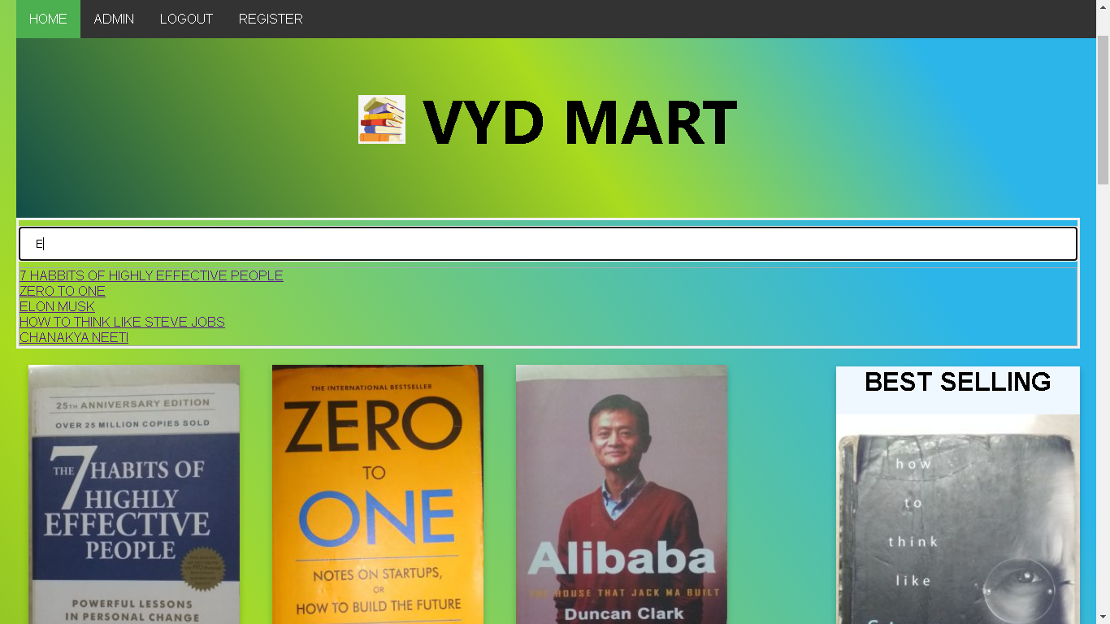

**CONCLUSION**

Thus, implemented search functionality using Php and ajax

**Experiment 7**

# **AIM:** Create a web application using laravel framework. The web application should contain laravels user registration process

**THEORY:**

Laravel is an open-source PHP framework, which is robust and easy to understand. It follows a model-view-controller design pattern. Laravel reuses the existing components of different frameworks which helps in creating a web application. The web application thus designed is more structured and pragmatic.

Laravel offers a rich set of functionalities which incorporates the basic features of PHP frameworks like CodeIgniter, Yii and other programming languages like Ruby on Rails. Laravel has a very rich set of features which will boost the speed of web development.

If you are familiar with Core PHP and Advanced PHP, Laravel will make your task easier. It saves a lot time if you are planning to develop a website from scratch. Moreover, a website built in Laravel is secure and prevents several web attacks.

Advantages of Laravel

Laravel offers you the following advantages, when you are designing a web application based on it −

* The web application becomes more scalable, owing to the Laravel framework.
* Considerable time is saved in designing the web application, since Laravel reuses the components from other framework in developing web application.
* It includes namespaces and interfaces, thus helps to organize and manage resources.

**PROGRAM:**

**APP HOME PART**

<!DOCTYPE html>

<html lang="{{ str_replace('_', '-', app()->getLocale()) }}">

<head>

    <meta charset="utf-8">

    <meta name="viewport" content="width=device-width, initial-scale=1">

    <!-- CSRF Token -->

    <meta name="csrf-token" content="{{ csrf_token() }}">

    <title>{{ config('app.name', 'Laravel') }}</title>

    <!-- Scripts -->

    <script src="{{ asset('js/app.js') }}" defer></script>

    <!-- Fonts -->

    <link rel="dns-prefetch" href="//fonts.gstatic.com">

    <link href="https://fonts.googleapis.com/css?family=Nunito" rel="stylesheet" type="text/css">

    <!-- Styles -->

    <link href="{{ asset('css/app.css') }}" rel="stylesheet">

</head>

<body>

    <div id="app">

        <nav class="navbar navbar-expand-md navbar-light navbar-laravel">

            <div class="container">

                <a class="navbar-brand d-flex align-items-center" href="{{ url('/') }}">

                    <div><img src="VYDMART.png" style="height: 20px; border-right: 1px solid #333;" class="pr-3"></div>

                    <div class="pl-3">VYD MART</div>

                </a>

                <button class="navbar-toggler" type="button" data-toggle="collapse" data-target="#navbarSupportedContent" aria-controls="navbarSupportedContent" aria-expanded="false" aria-label="{{ __('Toggle navigation') }}">

                    <span class="navbar-toggler-icon"></span>

                </button>

                <div class="collapse navbar-collapse" id="navbarSupportedContent">

                    <!-- Left Side Of Navbar -->

                    <ul class="navbar-nav mr-auto">

                    </ul>

                    <!-- Right Side Of Navbar -->

                    <ul class="navbar-nav ml-auto">

                        <!-- Authentication Links -->

                        @guest

                            <li class="nav-item">

                                <a class="nav-link" href="{{ route('login') }}">{{ __('Login') }}</a>

                            </li>

                            @if (Route::has('register'))

                                <li class="nav-item">

                                    <a class="nav-link" href="{{ route('register') }}">{{ __('Register') }}</a>

                                </li>

                            @endif

                        @else

                            <li class="nav-item dropdown">

                                <a id="navbarDropdown" class="nav-link dropdown-toggle" href="#" role="button" data-toggle="dropdown" aria-haspopup="true" aria-expanded="false" v-pre>

                                    {{ Auth::user()->username }} <span class="caret"></span>

                                </a>

                                <div class="dropdown-menu dropdown-menu-right" aria-labelledby="navbarDropdown">

                                    <a class="dropdown-item" href="{{ route('logout') }}"

                                       onclick="event.preventDefault();

                                                     document.getElementById('logout-form').submit();">

                                        {{ __('Logout') }}

                                    </a>

                                    <form id="logout-form" action="{{ route('logout') }}" method="POST" style="display: none;">

                                        @csrf

                                    </form>

                                </div>

                            </li>

                            <div class="header">

                                <h1 style="   padding: 14px 16px;  text-align: center;font-family: 'Segoe UI', Roboto, Oxygen, Ubuntu, Cantarell, 'Open Sans', 'Helvetica Neue', sans-serif"> <img src="VYDMART.png" alt="" height="60px"><a href="/ecom">ENTER VYD MART</a> </h1>

                              </div>

                        @endguest

                    </ul>

                </div>

            </div>

        </nav>

        <main class="py-4">

            @yield('content')

            <div class="footer">

                <div>

                  <p style="   padding: 14px 16px;  text-align: center;font-family: 'Segoe UI', Roboto, Oxygen, Ubuntu, Cantarell, 'Open Sans', 'Helvetica Neue', sans-serif"> <img src="VYDMART.png" alt="" height="60px">Copyright© <a href="http://vinaypanchal.com/">VINAY PANCHAL</a> All right reserved.</p>

                </div>

              </div>

        </main>

    </div>

</body>

</html>

**USER REGISTRATION PART**

@extends('layouts.app')

@section('content')

<div class="container">

    <div class="row justify-content-center">

        <div class="col-md-8">

            <div class="card">

                <div class="card-header">{{ __('Register') }}</div>

                <div class="card-body">

                    <form method="POST" action="{{ route('register') }}">

                        @csrf

                        <div class="form-group row">

                            <label for="name" class="col-md-4 col-form-label text-md-right">{{ __('Name') }}</label>

                            <div class="col-md-6">

                                <input id="name" type="text" class="form-control{{ $errors->has('name') ? ' is-invalid' : '' }}" name="name" value="{{ old('name') }}" autocomplete="name" autofocus>

                                @if ($errors->has('name'))

                                    <span class="invalid-feedback" role="alert">

                                        <strong>{{ $errors->first('name') }}</strong>

                                    </span>

                                @endif

                            </div>

                        </div>

                        <div class="form-group row">

                            <label for="email" class="col-md-4 col-form-label text-md-right">{{ __('E-Mail Address') }}</label>

                            <div class="col-md-6">

                                <input id="email" type="email" class="form-control{{ $errors->has('email') ? ' is-invalid' : '' }}" name="email" value="{{ old('email') }}" autocomplete="email">

                                @if ($errors->has('email'))

                                    <span class="invalid-feedback" role="alert">

                                        <strong>{{ $errors->first('email') }}</strong>

                                    </span>

                                @endif

                            </div>

                        </div>

                        <div class="form-group row">

                            <label for="username" class="col-md-4 col-form-label text-md-right">Username</label>

                            <div class="col-md-6">

                                <input id="username" type="username" class="form-control{{ $errors->has('username') ? ' is-invalid' : '' }}" name="username" value="{{ old('username') }}" autocomplete="username">

                                @if ($errors->has('username'))

                                    <span class="invalid-feedback" role="alert">

                                        <strong>{{ $errors->first('username') }}</strong>

                                    </span>

                                @endif

                            </div>

                        </div>

                        <div class="form-group row">

                            <label for="password" class="col-md-4 col-form-label text-md-right">{{ __('Password') }}</label>

                            <div class="col-md-6">

                                <input id="password" type="password" class="form-control{{ $errors->has('password') ? ' is-invalid' : '' }}" name="password" autocomplete="new-password">

                                @if ($errors->has('password'))

                                    <span class="invalid-feedback" role="alert">

                                        <strong>{{ $errors->first('password') }}</strong>

                                    </span>

                                @endif

                            </div>

                        </div>

                        <div class="form-group row">

                            <label for="password-confirm" class="col-md-4 col-form-label text-md-right">{{ __('Confirm Password') }}</label>

                            <div class="col-md-6">

                                <input id="password-confirm" type="password" class="form-control" name="password_confirmation" autocomplete="new-password">

                            </div>

                        </div>

                        <div class="form-group row mb-0">

                            <div class="col-md-6 offset-md-4">

                                <button type="submit" class="btn btn-primary">

                                    {{ __('Register') }}

                                </button>

                            </div>

                        </div>

                    </form>

                </div>

            </div>

        </div>

    </div>

</div>

@endsection

**SOURCE CODE OF ENTIRE EXPERIMENT ON**

<https://github.com/vinaynpp/wdl>

**OUTPUT:**

**APP HOME PART**

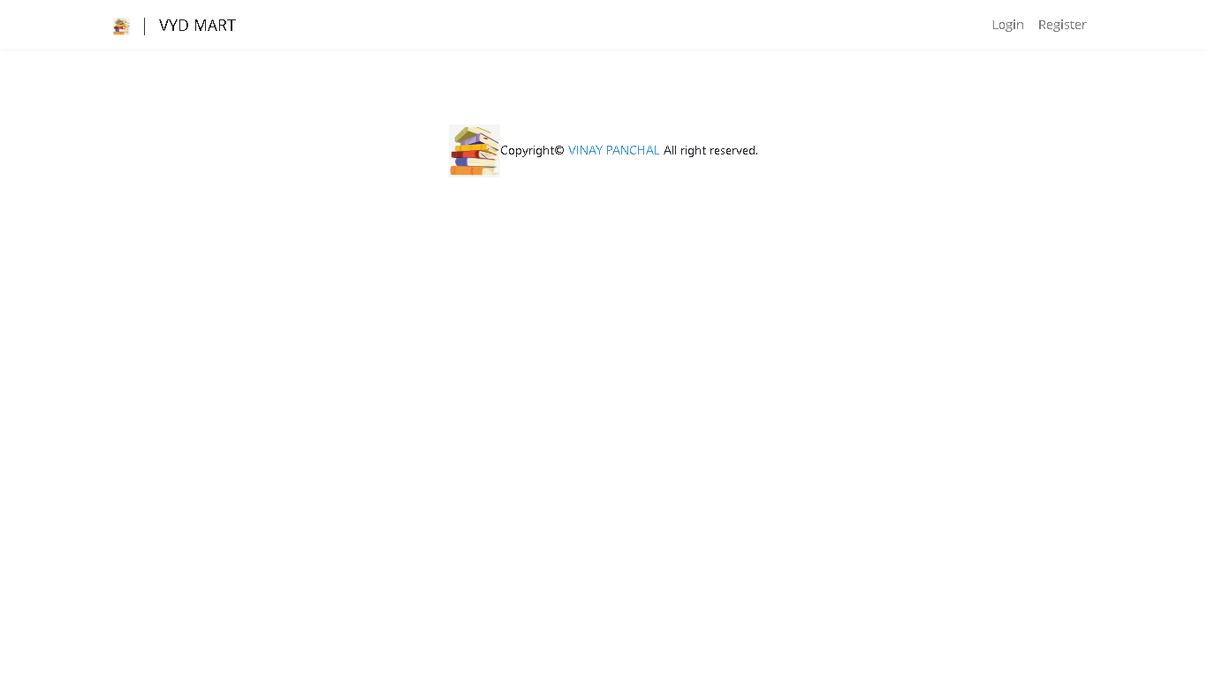

**USER REGISTRATION PART**

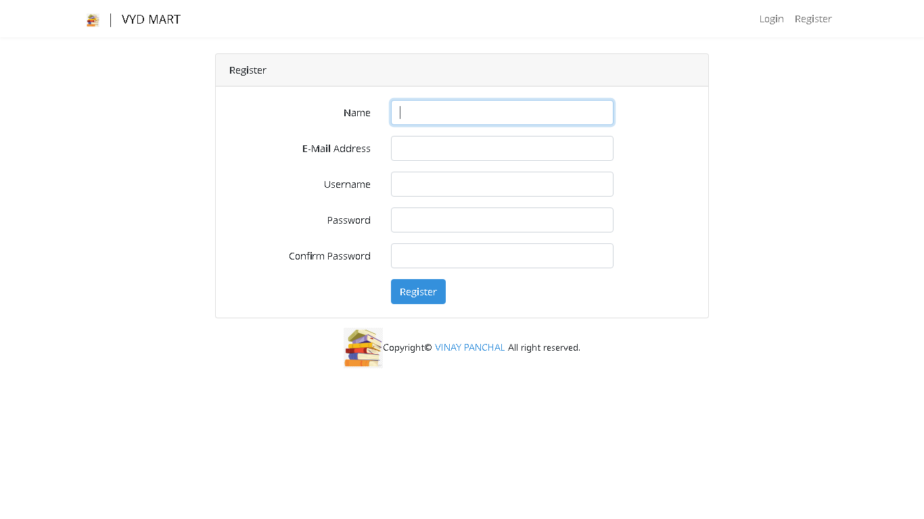

**CONCLUSION**

Thus,created a web application using laravel framework

**Experiment 8**

# **AIM:** Using laravel framework sample web application of your choice. The web application should interact with mysql database using models, controllers

**THEORY:**

Laravel is an open-source PHP framework, which is robust and easy to understand. It follows a model-view-controller design pattern. Laravel reuses the existing components of different frameworks which helps in creating a web application. The web application thus designed is more structured and pragmatic.

Laravel offers a rich set of functionalities which incorporates the basic features of PHP frameworks like CodeIgniter, Yii and other programming languages like Ruby on Rails. Laravel has a very rich set of features which will boost the speed of web development.

If you are familiar with Core PHP and Advanced PHP, Laravel will make your task easier. It saves a lot time if you are planning to develop a website from scratch. Moreover, a website built in Laravel is secure and prevents several web attacks.

Advantages of Laravel

Laravel offers you the following advantages, when you are designing a web application based on it −

* The web application becomes more scalable, owing to the Laravel framework.
* Considerable time is saved in designing the web application, since Laravel reuses the components from other framework in developing web application.
* It includes namespaces and interfaces, thus helps to organize and manage resources.

**PROGRAM:**

**APP LOGIN PART**

@extends('layouts.app')

@section('content')

<div class="container">

    <div class="row justify-content-center">

        <div class="col-md-8">

            <div class="card">

                <div class="card-header">{{ __('Login') }}</div>

                <div class="card-body">

                    <form method="POST" action="{{ route('login') }}">

                        @csrf

                        <div class="form-group row">

                            <label for="email" class="col-md-4 col-form-label text-md-right">{{ __('E-Mail Address') }}</label>

                            <div class="col-md-6">

                                <input id="email" type="email" class="form-control{{ $errors->has('email') ? ' is-invalid' : '' }}" name="email" value="{{ old('email') }}" required autocomplete="email" autofocus>

                                @if ($errors->has('email'))

                                    <span class="invalid-feedback" role="alert">

                                        <strong>{{ $errors->first('email') }}</strong>

                                    </span>

                                @endif

                            </div>

                        </div>

                        <div class="form-group row">

                            <label for="password" class="col-md-4 col-form-label text-md-right">{{ __('Password') }}</label>

                            <div class="col-md-6">

                                <input id="password" type="password" class="form-control{{ $errors->has('password') ? ' is-invalid' : '' }}" name="password" required autocomplete="current-password">

                                @if ($errors->has('password'))

                                    <span class="invalid-feedback" role="alert">

                                        <strong>{{ $errors->first('password') }}</strong>

                                    </span>

                                @endif

                            </div>

                        </div>

                        <div class="form-group row">

                            <div class="col-md-6 offset-md-4">

                                <div class="form-check">

                                    <input class="form-check-input" type="checkbox" name="remember" id="remember" {{ old('remember') ? 'checked' : '' }}>

                                    <label class="form-check-label" for="remember">

                                        {{ __('Remember Me') }}

                                    </label>

                                </div>

                            </div>

                        </div>

                        <div class="form-group row mb-0">

                            <div class="col-md-8 offset-md-4">

                                <button type="submit" class="btn btn-primary">

                                    {{ __('Login') }}

                                </button>

                                @if (Route::has('password.request'))

                                    <a class="btn btn-link" href="{{ route('password.request') }}">

                                        {{ __('Forgot Your Password?') }}

                                    </a>

                                @endif

                            </div>

                        </div>

                    </form>

                </div>

            </div>

        </div>

    </div>

</div>

@endsection

**APP ENVIRONMENT CONFIG PART**

APP_NAME=Laravel

APP_ENV=local

APP_KEY=

APP_DEBUG=true

APP_URL=http://localhost

LOG_CHANNEL=stack

LOG_LEVEL=debug

DB_CONNECTION=mysql

DB_HOST=127.0.0.1

DB_PORT=3306

DB_DATABASE=laravel

DB_USERNAME=root

DB_PASSWORD=

BROADCAST_DRIVER=log

CACHE_DRIVER=file

QUEUE_CONNECTION=sync

SESSION_DRIVER=file

SESSION_LIFETIME=120

REDIS_HOST=127.0.0.1

REDIS_PASSWORD=null

REDIS_PORT=6379

MAIL_MAILER=smtp

MAIL_HOST=smtp.mailtrap.io

MAIL_PORT=2525

MAIL_USERNAME=null

MAIL_PASSWORD=null

MAIL_ENCRYPTION=null

MAIL_FROM_ADDRESS=null

MAIL_FROM_NAME="${APP_NAME}"

**MAIN CONTROLLER PART**

<?php

namespace App\Http\Controllers;

use Illuminate\Http\Request;

use App\Http\Controllers\Auth\LoginController;

class PagesController extends Controller

{

    public function index(){

        return view('pages.index');

    }

}

**MAIN USER CONTROLLER PART**

<?php

namespace App\Models;

use Illuminate\Contracts\Auth\MustVerifyEmail;

use Illuminate\Database\Eloquent\Factories\HasFactory;

use Illuminate\Foundation\Auth\User as Authenticatable;

use Illuminate\Notifications\Notifiable;

class User extends Authenticatable

{

    use HasFactory, Notifiable;

    /**

     * The attributes that are mass assignable.

     *

     * @var array

     */

    protected $fillable = [

        'name',

        'email',

        'password',

    ];

    /**

     * The attributes that should be hidden for arrays.

     *

     * @var array

     */

    protected $hidden = [

        'password',

        'remember_token',

    ];

    /**

     * The attributes that should be cast to native types.

     *

     * @var array

     */

    protected $casts = [

        'email_verified_at' => 'datetime',

    ];

}

**SOURCE CODE OF ENTIRE EXPERIMENT ON**

<https://github.com/vinaynpp/wdl>

**OUTPUT:**

**APP LOGIN PART**

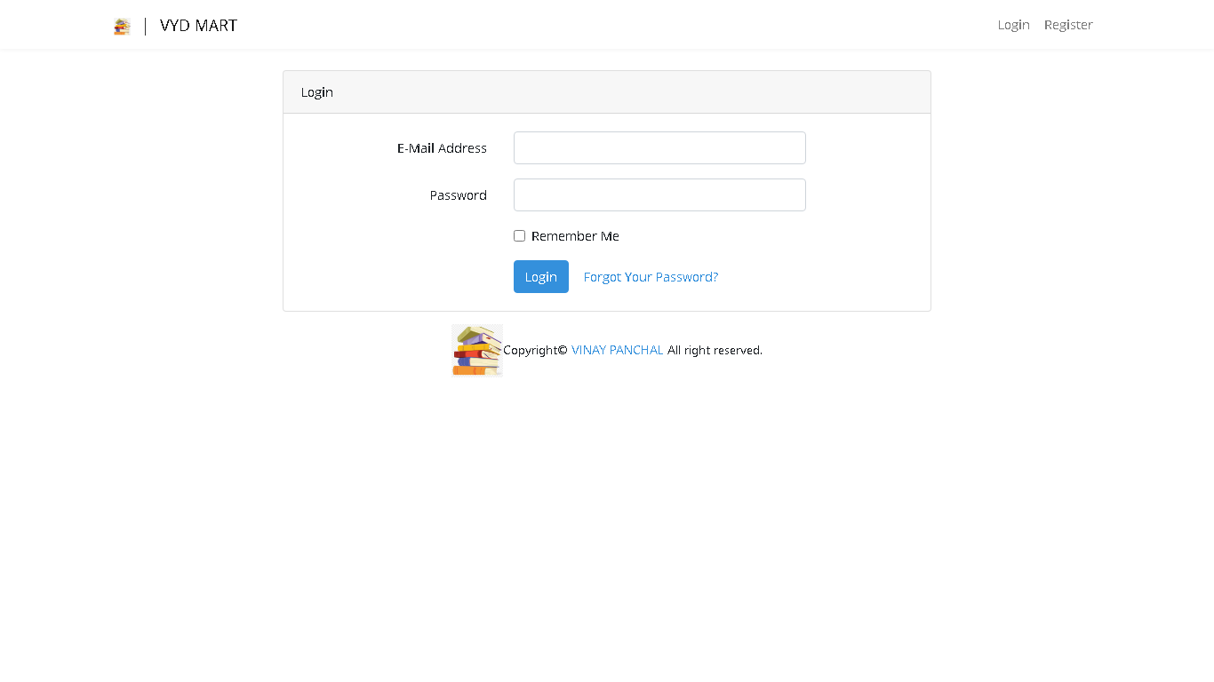

**CONCLUSION**

Thus, updated a web application using Laravel framework

**Experiment 9**

# **AIM:** Host the web application created in Exp 8 using Domain Registration Process

**THEORY:**

Web Hosting and Domain Registration are two elements of running a website. But it’s important to understand the difference and use cases.

Web Hosting is an account on a computer (aka server) that can store and serve website files via the Internet.

Domain Registration is leasing a human-readable word (e.g., amazon.com) that directs people to specific website files via a browser.

As an analogy, a domain is an “address” on the Internet. Hosting is the “land” or space where your website files live.

That’s the short version. But there’s more to web hosting vs. domain registration than their definition.

How Hosting & Domains Work

Web hosting and domain registration are frequently paired together. But it’s important to understand exactly what they do.

Domain Registration

Internet addresses are technically “IP Addresses.” IP addresses are a long series of numbers that make no sense to humans.

So instead of typing in 192.168.0.1.1 to access a website, the website owner can register a domain that will route to that specific IP address.

When you register a domain name, you are leasing it from the Internet Corporation for Names and Numbers (ICANN). ICANN provides domains via approved registrars.

A domain does not do anything on its own. Registration provides you the right to “point” your domain wherever you want.

You can tell it to redirect to another website – But usually, you’ll want it to direct browsers to your website…on your hosting account.

You can read more in Domain Names, Explained post.

Web Hosting

Web hosting is an account on a web server that “hosts” your website files.

If you do not have a domain “pointed” to your hosting account, you can access it with a string of numbers in an IP address.

While you can technically build your own server at home, most people buy hosting from a hosting company.

A hosting company is a company that owns a bunch of pre-configured servers that they lease out according to different hosting plans.

They will usually include instructions on how to “point” your domain to your hosting account. They’ll also provide instructions for software to build & manage your website.

You can read more in Website Hosting, Explained post.

But there are usually a few other terms that confuse issues.

**PROGRAM:**

**MAIN CONTROLLER PART**

<?php

namespace App\Http\Controllers;

use Illuminate\Http\Request;

use App\Http\Controllers\Auth\LoginController;

class PagesController extends Controller

{

    public function index(){

        return view('pages.index');

    }

}

**MAIN USER CONTROLLER PART**

<?php

namespace App\Models;

use Illuminate\Contracts\Auth\MustVerifyEmail;

use Illuminate\Database\Eloquent\Factories\HasFactory;

use Illuminate\Foundation\Auth\User as Authenticatable;

use Illuminate\Notifications\Notifiable;

class User extends Authenticatable

{

    use HasFactory, Notifiable;

    /**

     * The attributes that are mass assignable.

     *

     * @var array

     */

    protected $fillable = [

        'name',

        'email',

        'password',

    ];

    /**

     * The attributes that should be hidden for arrays.

     *

     * @var array

     */

    protected $hidden = [

        'password',

        'remember_token',

    ];

    /**

     * The attributes that should be cast to native types.

     *

     * @var array

     */

    protected $casts = [

        'email_verified_at' => 'datetime',

    ];

}

**SOURCE CODE OF ENTIRE EXPERIMENT ON**

<https://github.com/vinaynpp/wdl>

**OUTPUT:**

**DNS SETTINGS PART**

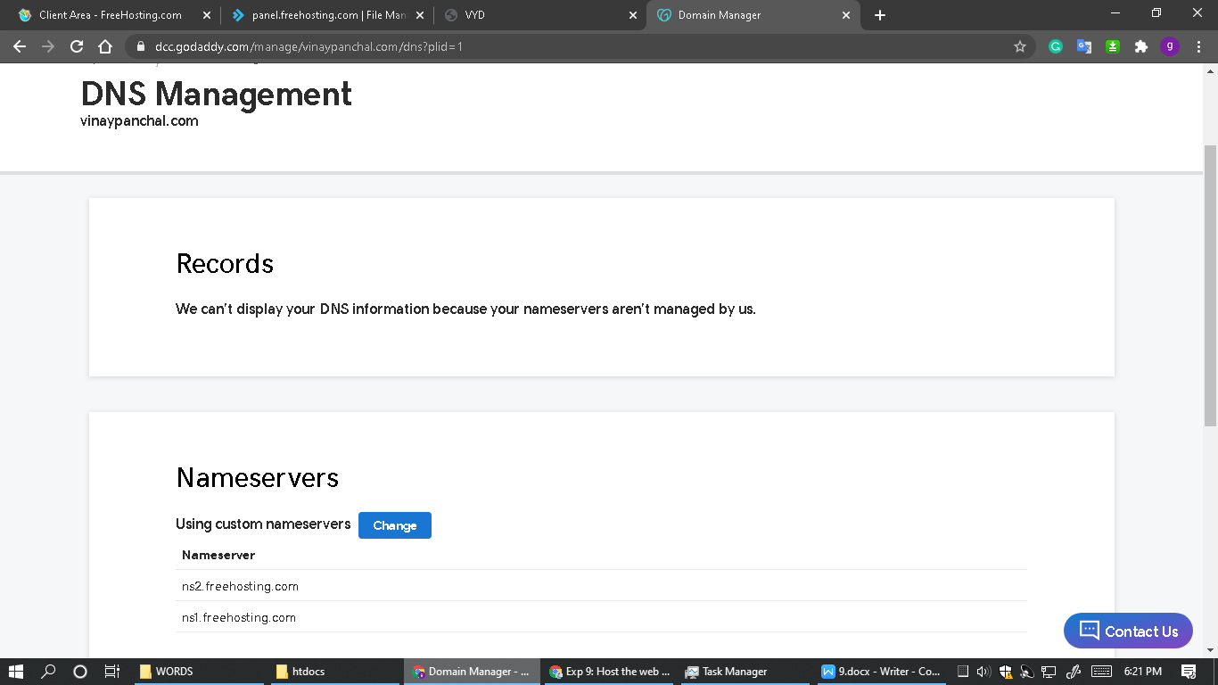

**HOSTING PANEL PART**

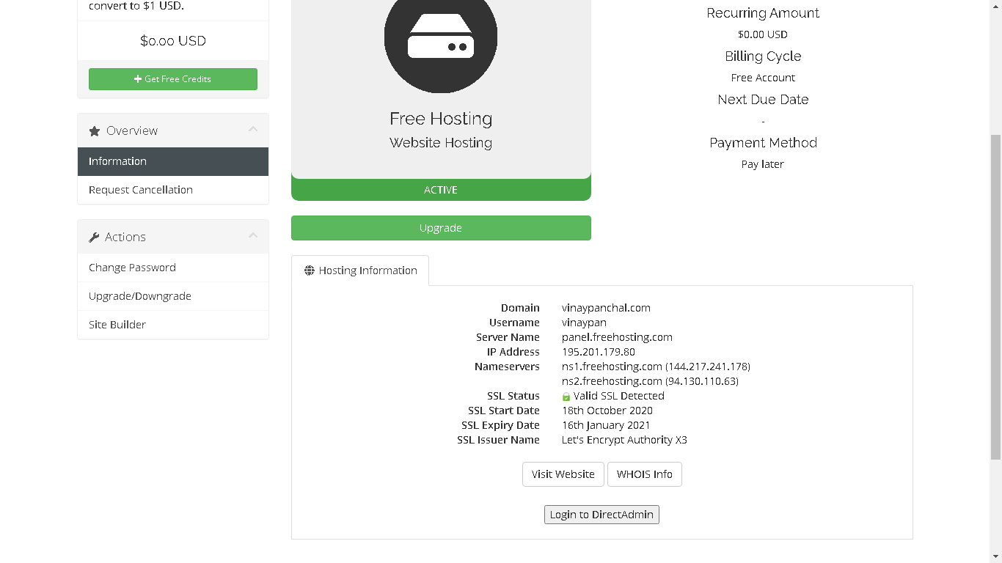

**HOSTED LARAVEL APP**

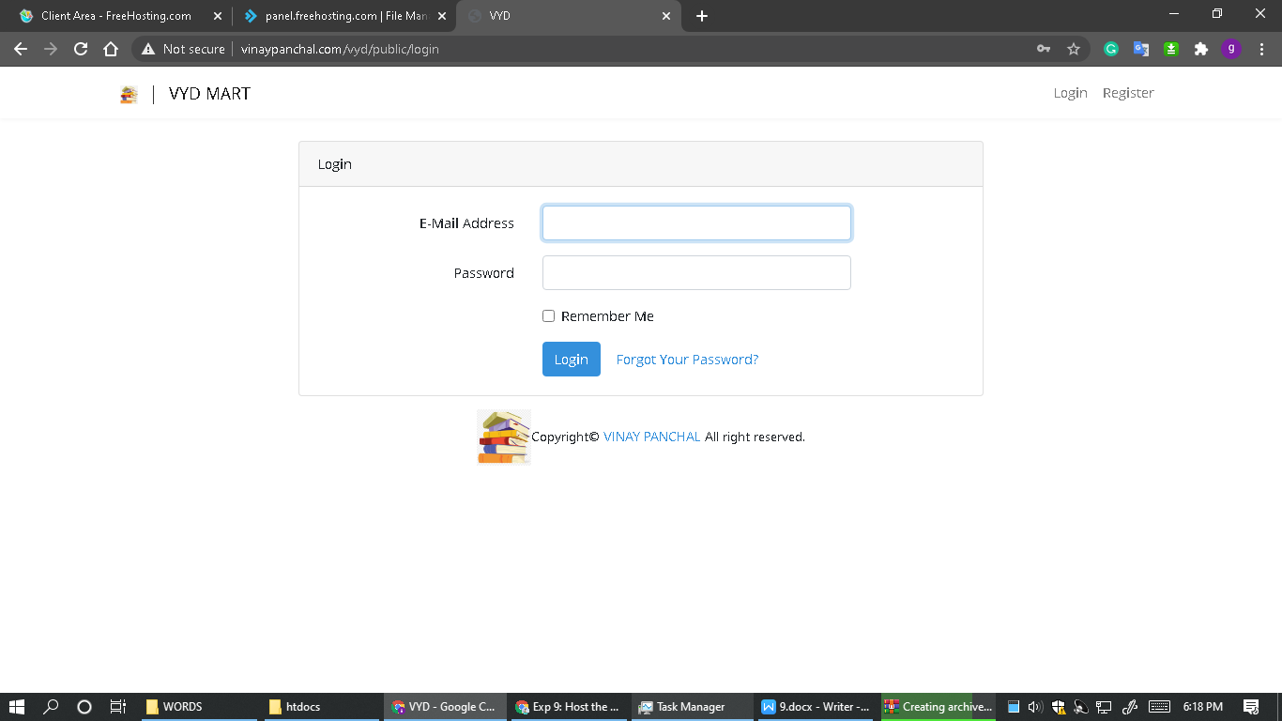

**CONCLUSION**

# Hence hosted the web application created in Exp 8 using Domain Registration Process

**RBPMS (MINI-PROJECT)**

**RESOURCE BASED PROJECT MANAGEMENT SYSTEM**

**THEORY**

The entire system of RESOURCE BASE PROJECT MANAGEMENT is designed to keep all your team’s tasks in one place ,collaborate and work in real time for real results, the most powerful and simple way to collaborate with your team.

**Problem statement:**

A combination of HRM(human resource manager) and PMS(project management system) is integrated .

Company has a manager who controls and assigns project to employees under him. Manager decides which project to be assigned , on the basis of employee's credentials like skills, experience and training. Project's nature can be acknowledged by its progress status, description and time limit.

**OVERVIEW OF PROJECT**



**LOGIN PAGE OF PROJECT**

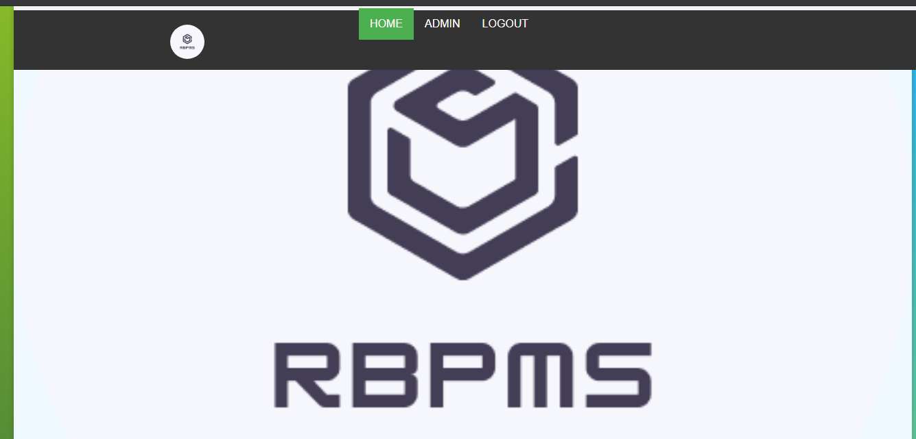

**ADMIN PANEL OF PROJECT**

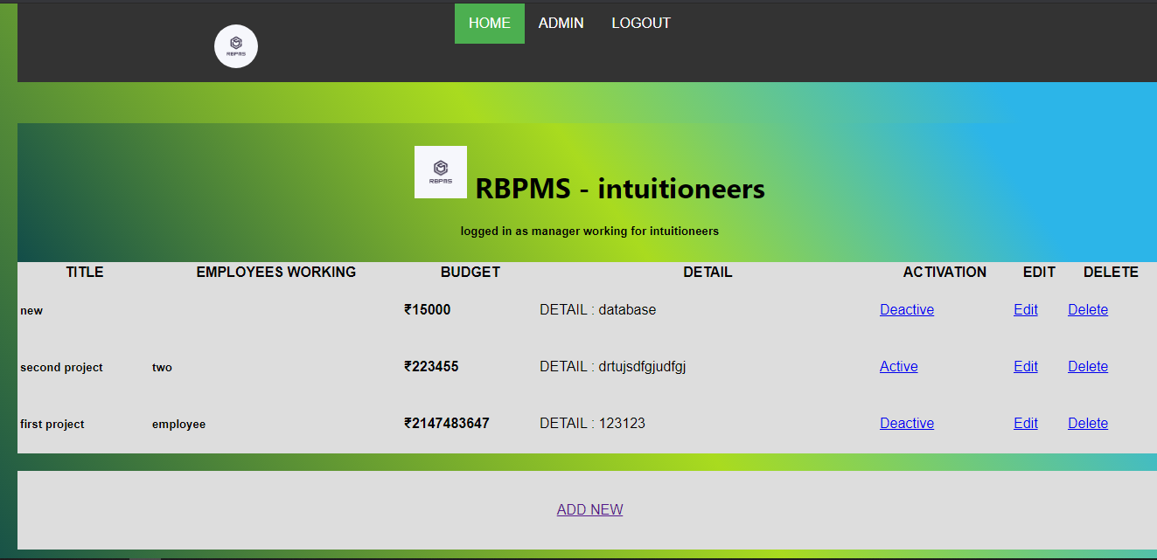

**DATABASE STRUCTURE OF PROJECT**

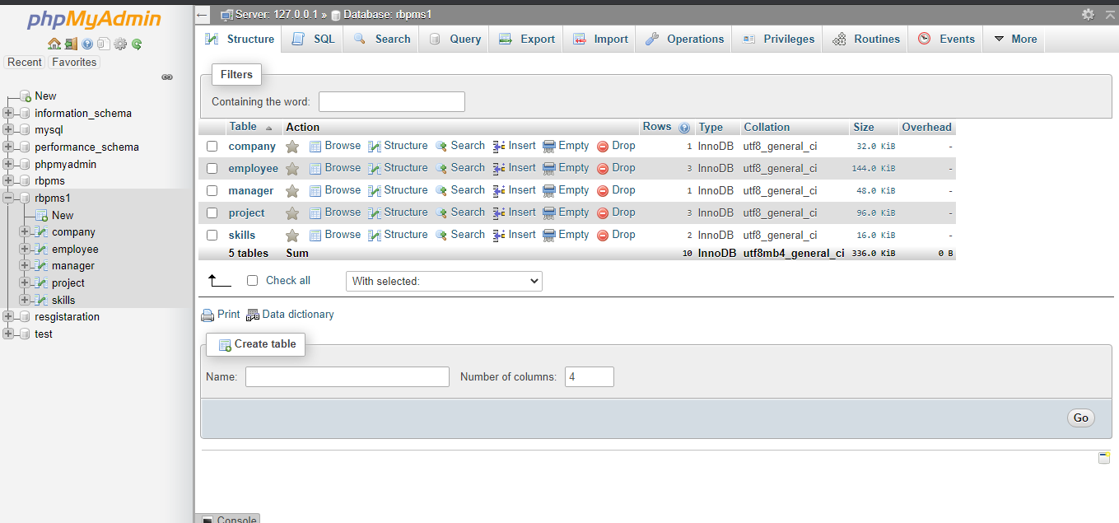

**PROJECT TABLE OF PROJECT**

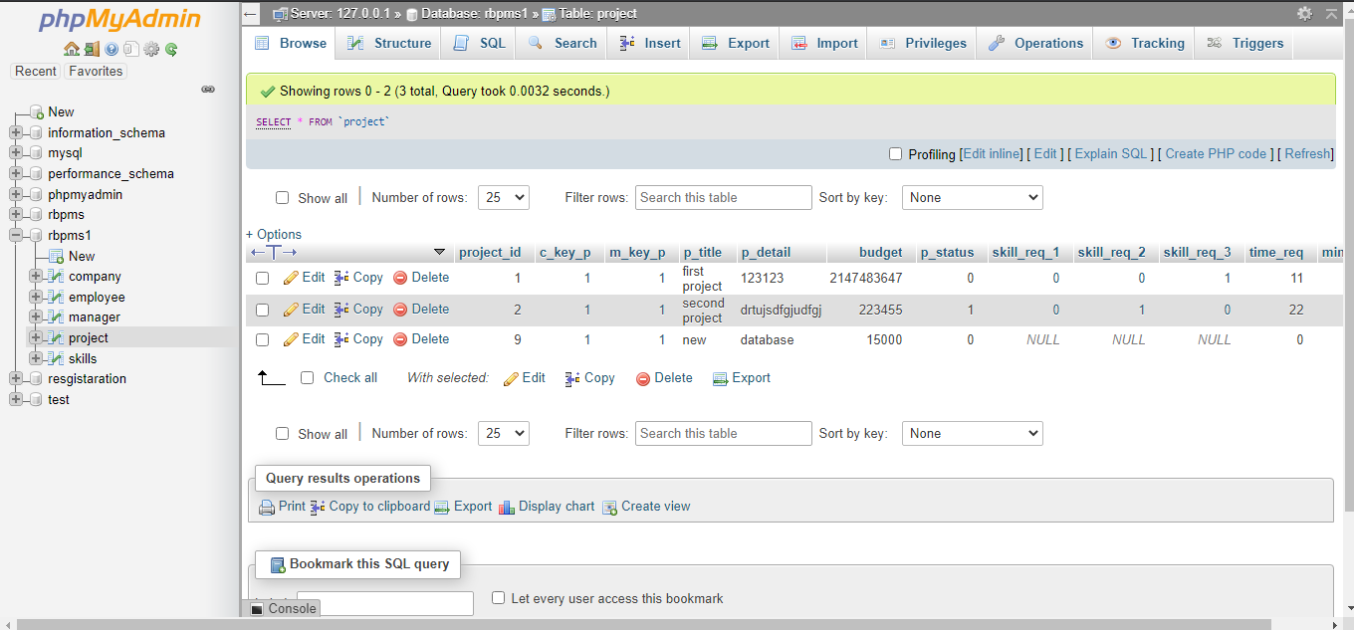

**HOSTED ENTIRE PROJECT ON**

<http://www.vinaypanchal.com/rbpms>

**SOURCE CODE OF ENTIRE PROJECT ON**

<https://github.com/vinaynpp/wdl>